CHEMISTRY NOTES
*not fully inclusive of everything in detail, use textbook to get more notes*
Kyla Orchard
Table of Contents
EQUATIONS 2
RANDOM NOTES 2
EQUILIBRIUM 2
CHANGES AT EQUILIBRIUM 2
TYPES OF CHEMICAL REACTIONS 3
LeChatelier’s PRINCIPLE 5
DYNAMIC EQUILIBRIUM 7
CALCULATIONS 9
CONVERTING UNITS 9
MEASUREMENTS AND UNITS 11
SIGNIFICANT FIGURES IN MEASUREMENT 13
ACIDS AND BASES 14
PROPERTIES OF ACIDS AND BASES 14
HYDROGEN IONS, ACIDITY AND pH 16
ACID AND BASE THEORIES 17
STRONG OR WEAK 19
TITRATIONS, SALT HYDROLYSIS AND BUFFERS 21
TITRATION CALCULATIONS 23
REDOX 24
OXIDATION – REDUCTION 24
OXIDATION NUMBER 25
REDOX EQUATIONS 26
GALVANIC CELLS 27
OTHER CELLS AND ELECTROLYSIS 31
ORGANIC CHEMISTRY 35
Y11 REVISION AND FUNCTIONAL GROUPS 35
ALCOHOLS 38
OTHER ORGANIC COMPOUNDS 40
POLYMERS + PLASTICS 42
SOAPS AND PROTEINS 45
SOAPS + DETERGENTS 45
PROTEINS 48
SYNTHESIS 51

unit three
steps for calculation Qs:
- balanced equation
- find mols from question
- find mols of other stuff based on the balanced equation
- answer Qu (find mass, M etc.)
- generally concentration, volume, mass or mols

EQUATIONS
K = $\frac{{[Product 1]}^{coefficient 2} * {[Product 2] }^{coefficient 2}}{ {[Reactant 1]}^{coefficient 1} * {[Reactant 2] }^{coefficient 2}}$

Combined gas law
$\frac{P_{1}V_{1}}{T_{1}}=\frac{P_{2}V_{2}}{T_{2}}$
Degrees = K
P = kPa
Ideal gas equation
$PV=nRT$

RANDOM NOTES
- Nitrates, potassium and sodium are soluble

EQUILIBRIUM

CHANGES AT EQUILIBRIUM
A system is able to reach equilibrium if it is:
- A closed system
- A reversible reaction (chemical or physical)

At equilibrium there are constant macroscopic properties as the rates of the forward and reverse reactions are equal

It is described as a dynamic equilibrium as at a particle level there are reactions still occurring

POSITION AT EQUILIBRIUM
- At equilibrium the ratio of the concentration of products to the concentration of reactants is reflected by the Equilibrium Constant
- We can also describe the position of equilibrium as left or right
  - This is specific to the reaction as it is written in the equation
  - Left = more reactants, right = more products

EQUILIBRIUM CONSTANT
At equilibrium there is a relationship between the concentration of product and reactants - the Equilibrium Law which determines the Equilibrium constant (K) for a reaction.

This is constant for a given reaction at a given temperature

This can be calculated by:
K = $\frac{{[Product 1]}^{coefficient 2} * {[Product 2] }^{coefficient 2}}{ {[Reactant 1]}^{coefficient 1} * {[Reactant 2] }^{coefficient 2}}$

Liquids and solids have unchanging concentrations and are not included in the equilibrium law

With solutions the moles/litre can be used.
With gases volume is often used as this is proportional to the concentration.

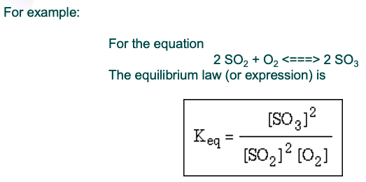

YIELD VS RATE
- The rate of the reaction refers to how quickly the reaction occurs
- The yield of the reaction refers to the amount of product produced
- In equilibrium, the position of equilibrium affects the yield, whereas the rate affects how quickly the yield is produced

CHANGES AT EQUILIBRIUM
- When changes are made to a system that is at equilibrium the forward, reverse or both reactions may be affected
- If the rate of either or both reaction is altered then the system will no longer be at equilibrium, and the system will adjust to reestablish equilibrium
- Therefore anything that changes the rate of a reaction may affect equilibrium

TYPES OF CHEMICAL REACTIONS
DECOMPOSITION OF CARBONATE BY HEATING
CuCO₃ 🡪

CuCO₃ 🡪 CuO + CO₂

DECOMPOSITION OF CARBONATE WITH AN ACID
CaCO₃ + HCl →
CO₃²⁻ + H⁺ →

CaCO₃ + 2HCl → CaCl₂ + CO₂ + H₂O
CO₃²⁻_{(s)} + 2H⁺_{(aq)} → CO_{2(g)} + H₂O_{(l)}

OXIDATION OF A METAL
Mg + O₂ →

2Mg + O₂ → 2MgO

REACTION OF AN ACTIVE METAL WITH A DILUTE ACID
Mg + HCl →
Mg + H⁺ →

Mg + 2HCl → MgCl₂ + H₂
Mg_{(s)} + 2H⁺_{(aq)} → Mg²⁺_{(aq)} + H_{2(g)}

PRECIPITATION REACTION
Pb(NO₃)₂ + KI →
Pb²⁺ + I⁻ 🡪

CuSO₄ + NaOH →
Cu²⁺ + OH⁻ →

Pb(NO₃)_{2(aq)} + 2KI_{(aq)} → PbI_{2(s)} + 2KNO_{3(aq)}
Pb²⁺_{(aq)} + 2I⁻_{(aq)} → PbI_{2(s)}

CuSO_{4(aq)} + 2NaOH_{(aq)} → Cu(OH)_{2(s)} + Na₂SO_{4(aq)}
Cu²⁺_{(aq)} + 2OH⁻_{(aq)} → Cu(OH)_{2(s)}

METAL DISPLACEMENT REACTION
CuSO₄ + Zn →
Cu²⁺ + Zn →

Pb(NO₃)₂ + Zn →
Pb²⁺ + Zn →

AgNO₃ + Cu →
Ag⁺ + Cu →

CuSO₄ + Zn → Cu + ZnSO₄
Cu²⁺_{(aq)} + Zn_{(s)} → Cu_{(s)} + Zn²⁺_{(aq)}

Pb(NO₃)₂ + Zn → Pb + Zn(NO₃)₂
Pb²⁺_{(aq)} + Zn_{(s)} → Pb_{(s)} + Zn²⁺_{(aq)}

2AgNO₃ + Cu → 2Ag + Cu(NO₃)₂
2Ag⁺_{(aq)} + Cu_{(s)} → 2Ag_{(s)} + Cu²⁺_{(aq)}

NEUTRALISATION REACTION
HCl + NaOH →
H⁺ + OH⁻ →

HCl + NaOH → NaCl + H₂O
H⁺_{(aq)} + OH⁻_{(aq)} → H₂O_{(l)}

LeChatelier’s PRINCIPLE
LeChatelier’s Principle summarises the way that a system will be affected by a change in equilibrium
- It states that if a change is made to a system that is at equilibrium, the system will act in such a way so as to partially counteract the change

LeChatelier’s Principle is used to predict the effect of changes made to a system at equilibrium
Collision theory is used to explain the reasons for the changes to equilibrium

CHANGES TO CONCENTRATION
- When the concentration of a reactant or product is changed the rate of the reaction which uses that substance will be altered
- Therefore, the system is no longer at equilibrium as the rates of the forward and reverse reactions are no longer equal
- The reaction that is now the fastest is said to be favoured and more of the products for that reaction will be made
- This will lead to a shift in the position of equilibrium
Both forward and reverse are sped up as increase in concentration
The main way this is done is by adding H₂O

CONCENTRATION – LeChatelier’s Principle
- When the concentration of a reactant or product is changed the system will act to counteract that change.
- If the concentration is increased (eg adding more of that substance) the reaction that uses that substance will be favoured.
- If the concentration of a substance is decreased (eg. The substance is removed or precipitated) then the reaction that produces that substance will be favoured.
- Adding more of a solid will not change the concentration of the substance, and therefore will not affect the position of equilibrium.
- Adding a substance will only affect equilibrium if it affects the concentration of one or more of the substances in the reaction.
- Therefore, adding a solid or liquid will not affect the position of equilibrium.

CHANGES TO VOLUME OR PRESSURE
- When the volume or pressure of a gaseous system is changed then the concentration of all the gases will be altered.
- If there are different number of moles of gases in the reactants and products when the rates of the 2 reactions will be affected to different extents.
- The reaction with the greater number of moles of gas as reactants will be effected more.
- Therefore this reaction will increase or decrease in rate more than the opposite one.
Volume decrease, pressure increase, system will favour the reaction that produces less moles of gas (and vice versa)
Diluting or concentrating an aqueous system will have the same effect on the aqueous substances

CHANGES TO VOLUME OR PRESSURE – LeChatelier’s Principle
- If the volume is decrease or the pressure increased, then the system will favour the reaction that produces less moles of gas.
- If the volume is increased or the pressure is decreased, then the system favour the reaction that produces more moles of gas.
- Diluting or concentrating an aqueous system will have the same affect on the aqueous substances.

CHANGES TO TEMPERATURE
- A change in temperature is the only change that will change the equilibrium constant.
  - Predict – LCP favours FR
- An increase in temperature will increase the reaction rate of both the forward and reverse reactions.
  - Explain – down T, down FRR + down RRR
- However the endothermic reaction (which consumes energy) will increase more.
  - Down FRR < down RRR
- A decrease in temperature will decrease the rates of both the forward and reverse reactions.
  - Because small [] of reactants and large [] products
  - Fewer collisions of reactants, more collisions of products
- However, the endothermic reaction (which produces energy) will decrease less. This means that the exothermic reaction is faster.
  - Favours FR

IN SUMMARY:
- If the temperature is increased the endothermic reaction is favoured.
- If the temperature is decreased the exothermic reaction is favoured.

- If the forward reaction is favoured there will be more products at the new equilibrium, and therefore K_{eq} will increase.
- If the reverse reaction is favoured there will be more reactants at the new equilibrium, and therefore K_{eq} will decrease.

EQUILIBRIUM CONSTANT CHANGES
For the following reaction, write how the each of the changes will affect the indicated quantity, assuming a container of fixed size. Write “increase”, “decrease”, or “no change”. (Or use an “up” arrow to indicate “increase”, and a “down” arrow to indicate “decrease”.) (For a chemical added, write how it would respond AFTER the addition.)

H₂(g) + Br₂(g) $⇌$ 2HBr(g) ΔHº = -103.7kJ

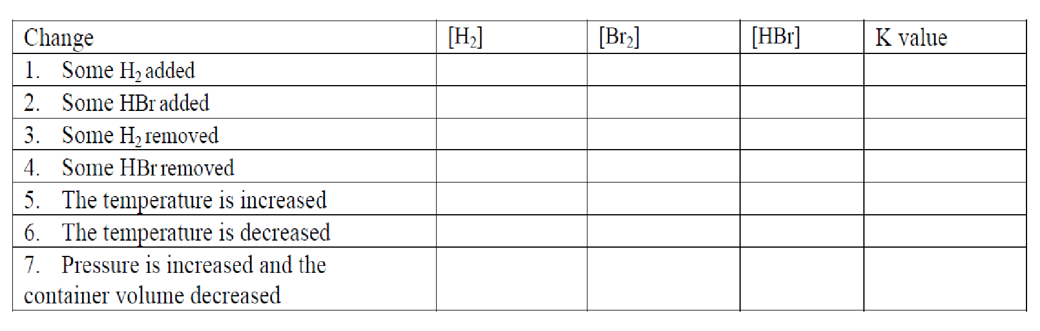

ADDING A CATALYST
- Adding a catalyst will not affect the position of equilibrium.
- The activation energy for both the forward and reverse reactions will be lowered, and therefore the rates of both reactions will increase.
- This means that equilibrium will be reached more quickly.
- Therefore the rate of attaining equilibrium will increase but the position of equilibrium (and therefore the yield) will be the same.

INCREASING THE SURFACE AREA
- Increasing the surface area of a substance will increase the rate of the reaction, but not the position of equilibrium.

DYNAMIC EQUILIBRIUM
When a reversible reaction in a closed system is able to continue until the rate of reactants forming products is the same as the rate of products forming reactants the system is in a state of dynamic equilibrium.

- At this point the amount of reactants and products remains constant.
- It does not mean that the amount of reactants and products are equal!
- When a system is at dynamic equilibrium the rates of the forward and reverse reactions are equal and constant.

REACHING EQUILIBRIUM
- Usually a system initially consists of reactants only.
- This means that their concentrations are high.
- Therefore initially the rate of the forward reaction is fast.
- At this time there are no products.
- This means that the rate of the reverse reaction is zero.

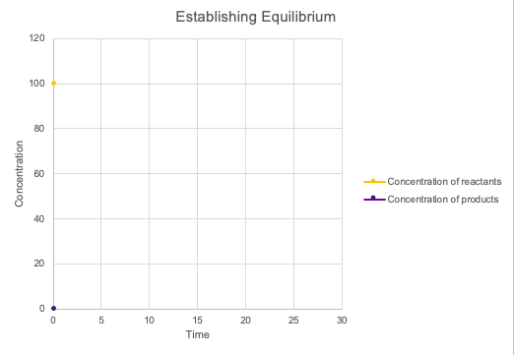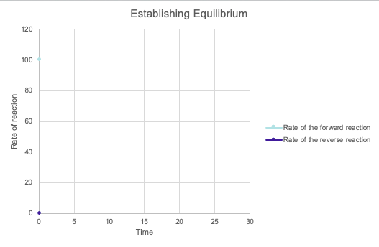
- As the reactants form products:
  - The concentration of reactants decreases
  - The concentration of products increases.
  - This means that:
    - The rate of the forward reaction decreases
    - The rate of the reverse reaction increases.

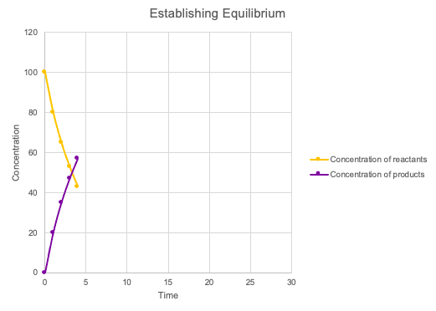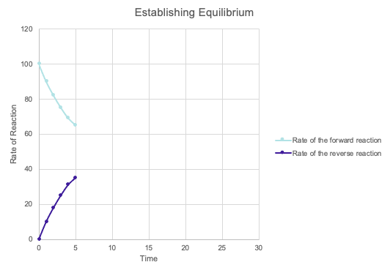
- This continues until:
  - The rate of the forward and reverse reactions are equal
  - The concentrations of the reactants and products remain constant.

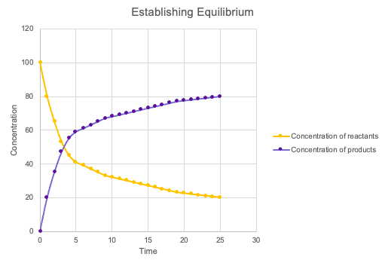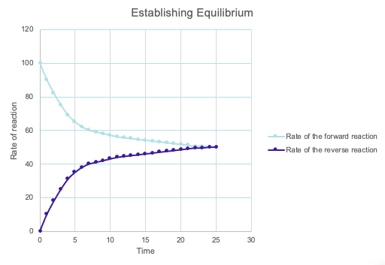

CONCENTRATION GRAPHS
Nitrosyl bromide (NOBr2) decomposes and reaches equilibrium according to the equation below.
2NOBr₂(g) 🡨🡪 2NO(g) + Br₂(g) ΔH < 0

A number of changes were imposed on the equilibrium mixture, as described in (a) and (b) below. Show the effects of these changes by extending the lines accordingly on the diagram shown, as the system re-establishes a new equilibrium in each case.

REACTION RATE GRAPHS
The graph drawn below shows the concentrations of the three substances in the reacting system given by the following equation, plotted against time
COCl₂(g) 🡨🡪 Cl₂(g) + CO(g) ΔH = +108 kJ
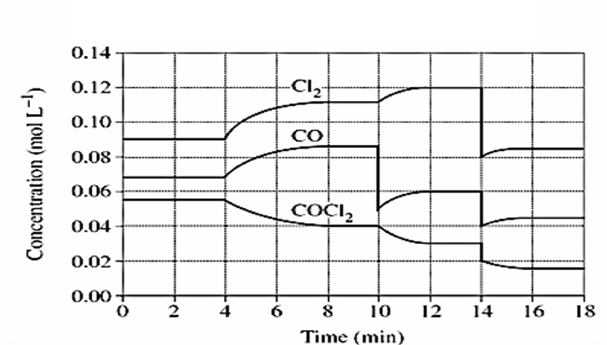

CALCULATIONS

CONVERTING UNITS
PRESSURE
Converting between atmospheres and millimeters of mercury.
One atm. equals 760.0 mm Hg, so there will be a multiplication or division based on the direction of the change.

Example #1: Convert 0.875 atm to mmHg.
Solution: multiply the atm value by 760.0 mmHg / atm.

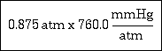
To atm ($×101.3$)
To kPa ($÷760$)

Example #2: Convert 745.0 mmHg to atm.
Solution: divide the mmHg value by 760.0 mmHg / atm

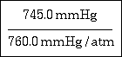
To atm ($÷101.3$)
To kPa ($×760$)

Combined gas law
$\frac{P_{1}V_{1}}{T_{1}}=\frac{P_{2}V_{2}}{T_{2}}$
Degrees = K
P = kPa
Ideal gas equation = $PV=nRT$

0 degrees = 273 degrees K

Converting between atmospheres and kilopascals.
One atm equals 101.325 kPa, so there will be a multiplication or division based on the direction of the change.

Example #3: Convert 0.955 atm to kPa.
Solution: multiply the atm value by 101.325 kPa / atm.

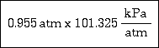

Example #4: Convert 98.35 kPa to atm.
Solution: divide the kPa value by 101.325 kPa / atm.

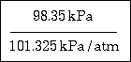

CONVERTING BETWEEN MILLIMETERS OF MERCURY AND KILOPASCALS
760.0 mmHg equals 101.325 kPa, so both values will be involved. This situation is slighly unusual because
most conversions involve a one, usually in the denominator. The conversion examples above are examples
of a one being involved. For example, 760.0 mmHg / 1.00 atm in examples 1 and 2. The 1.00 was assumed
to be present.
In this conversion, both 760.0 and 101.325 will be involved and the location of each (numerator or denominator)
will depend on the conversion.

Example #5: Convert 740.0 mmHg to kPa.

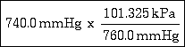

Example #6: Convert 99.25 kPa to mmHg.

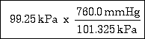

TEMPERATURE
K = ºC + 273
ºC = K - 273

MASS
1 g = 1000 mg
1 kg = 1000 g
1 t = 1000 kg

VOLUME
1 cm³ = 1 mL
1 L = 1000 mL
1 kL = 1000 L
1 cm³ = 1000 mm³
1 m³ = 10⁶ cm³

MEASUREMENTS AND UNITS
UNITS AND SYMBOLS
unit | symbol | physical quantity
metre | m | distance
second | s | time
kilogram | kg | mass
kelvin | K | thermodynamic temperature
mole | mol | amount of substance
candela | cd | luminous intensity

SCIENTIFIC NOTATION
0.0063 = 6.3 x 10⁻³
300 000 000 m.s⁻¹ = 3.0 x 10⁸ m.s⁻¹

PREFIXES AND CONVERSION FACTORS
Multiplying factor |  | prefix | symbol
1 000 000 000 000 | 10¹² | tera | T
1 000 000 000 | 10⁹ | giga | G
1 000 000 | 10⁶ | mega | M
1 000 | 10³ | kilo | k
0.01 | 10⁻² | centi | c
0.001 | 10⁻³ | milli | m
0.000 001 | 10⁻⁶ | micro | µ
0.000 000 001 | 10⁻⁹ | nano | n
0.000 000 000 001 | 10⁻¹² | pico | p

ACCURACY AND PRECISION
Instruments are said to be accurate if they truly reflect the quantity being measured.
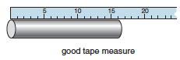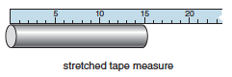
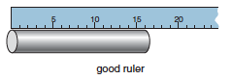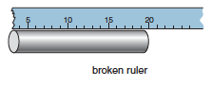

All measurements have some amount of uncertainty. The uncertainty is, indeed, a measure of the precision of an instrument.

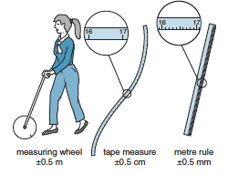

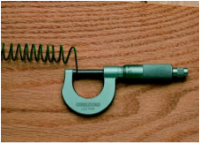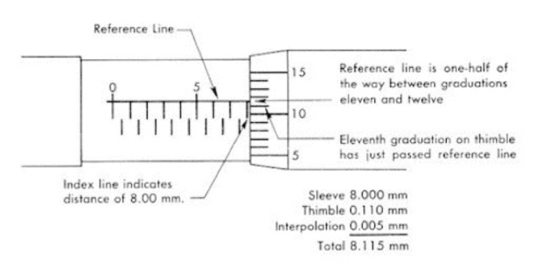

ESTIMATING THE UNCERTAINTY IN A RESULT
When adding or subtracting data, add the absolute uncertainty
When multiplying or dividing data, add the percentage uncertainties.
When raising the data to power n, multiply the percentage uncertainty by n.

SIGNIFICANT FIGURES
The answer should be rounded to the least quantity in the calculation.
eg. 2.34x10³ x 1.2 x 10⁴ = 2.8 x 10⁷

GRAPHICAL ANALYSIS OF DATA
Linear Relationship
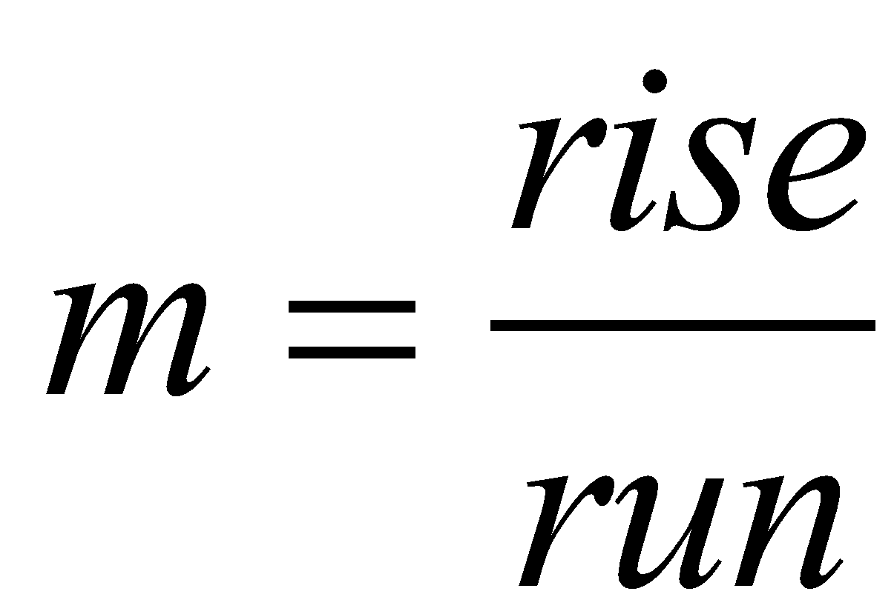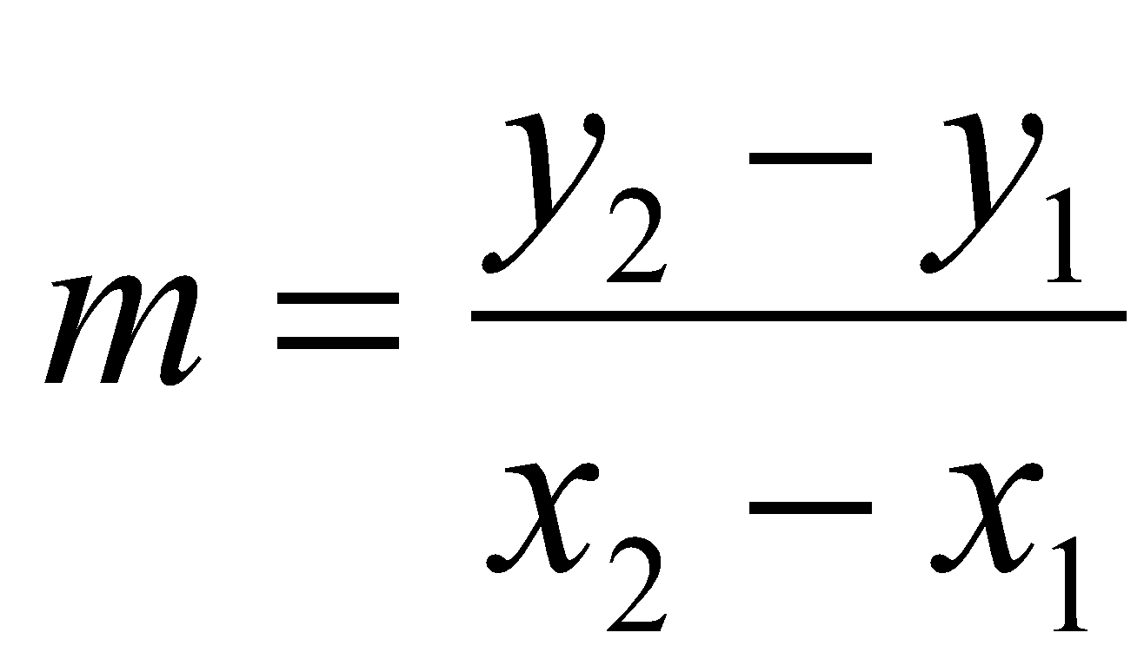

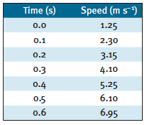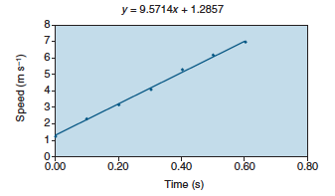

SIGNIFICANT FIGURES IN MEASUREMENT
- The numbers reported in a measurement are limited by the measuring tool
- Significant figures in a measurement include the known digits plus one estimated digit

COUNTING SIGNIFICANT FIGURES
Number of Significant Figures
38.15 cm = 4s.f
5.6 kg = 2s.f
65.6 g = 3s.f
122.55 m = 5s.f
Complete: All non-zero digits in a measured number are (significant or not significant).

LEADING ZEROS
Number of Significant Figures
0.008 mm = 1s.f
0.0156 mg = 3s.f
0.0042 L = 2s.f
0.000262 mL = 3s.f
Complete: Leading zeros in decimal numbers are (significant or not significant)

SANDWICHED ZEROS
Number of Significant Figures
50.8 mm = 3s.f
2001 s = 4s.f
0.702 tonnes = 3s.f
0.00405 m = 3s.f
Complete: Zeros between nonzero numbers are (significant or not significant).

TRAILING ZEROS
Number of Significant Figures
25000 km = 2s.f
200 yr = 1s.f
48600 L = 3s.f
25005000 g = 5s.f
Complete: Trailing zeros in numbers without decimals are (significant or not significant).

SIGNIFICANT FIGURES IN CALCULATIONS
- A calculated answer cannot be more precise than the measuring tool.
- A calculated answer must match the least precise measurement.
- Significant figures are needed for final answers from
  - adding or subtracting
  - multiplying or dividing

ADDING AND SUBTRACTING
The answer has the same number of decimal places as the measurement with the fewest decimal places.
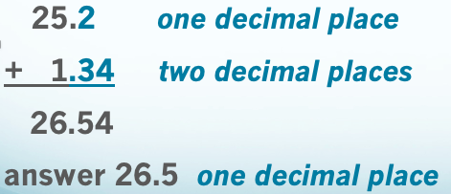

MULTIPLYING AND DIVIDING
Round (or add zeros) to the calculated answer until you have the same number of significant figures as the measurement with the fewest significant figures.

ACIDS AND BASES

PROPERTIES OF ACIDS AND BASES
PROPERTIES OF ACIDS
- They taste sour (don’t try this at home).
- They can conduct electricity.
- Can be strong or weak electrolytes in aqueous solution
Still strong when diluted
- React with metals to form H₂ gas.
- Change the color of indicators (for example: blue litmus turns to red).
- React with bases (metallic hydroxides) to form water and a salt.
- They have a pH of less than 7 (more on this concept of pH in a later lesson)
- They react with carbonates (CO₃²⁻) and bicarbonates (hydrogen carbonate HCO₃²⁻) to produce a salt, water, and carbon dioxide gas
- How do you know if a chemical is an acid?
  - It usually starts with Hydrogen.
  - HCl, H₂SO₄, HNO₃, etc. (but not water!)
These are the strong acids
Covalent molecular
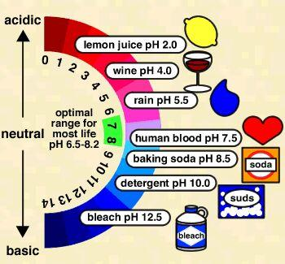
Acids react with active metals
Acids react with active metals to form salts and hydrogen gas:
HCl_{(aq)} + Mg_{(s)} 🡪 MgCl_{2(aq)} + H_{2(g)}

Acids React with Carbonates and Bicarbonates
HCl + NaHCO₃ 🡪 NaCl + H₂O + CO₂
Hydrochloric acid + sodium bicarbonate 🡪 salt + water + carbon dioxide
(An old-time home remedy for relieving an upset stomach)

Acids Neutralize Bases
HCl + NaOH 🡪 NaCl + H₂O
- Neutralization reactions ALWAYS produce a salt (which is an ionic compound) and water.
- Of course, it takes the right proportion of acid and base to produce a neutral salt

Sulfuric Acid = H2SO4
Highest volume production of any chemical in the U.S. (approximately 60 billion pounds/year)
Used in the production of paper
Used in production of fertilizers
Used in petroleum refining; auto batteries

Nitric Acid = HNO3
Used in the production of fertilizers
Used in the production of explosives
Nitric acid is a volatile acid – its reactive components evaporate easily
Stains proteins yellow (including skin!)

Hydrochloric Acid = HCl
Used in the “pickling” of steel
Used to purify magnesium from sea water
Part of gastric juice, it aids in the digestion of proteins
Sold commercially as Muriatic acid

Phosphoric Acid = H3PO4
A flavoring agent in sodas (adds “tart”)
Used in the manufacture of detergents
Used in the manufacture of fertilizers
Not a common laboratory reagent

Acetic Acid = HC2H3O2
(also called Ethanoic Acid, CH3COOH)
Used in the manufacture of plastics
Used in making pharmaceuticals
Acetic acid is the acid that is present in household vinegar

PROPERTIES OF BASES (metallic hydroxides)
React with acids to form water and a salt.
Taste bitter.
Feel slippery (don’t try this either).
Can be strong or weak electrolytes in aqueous solution
Change the color of indicators (red litmus turns blue).
Have a pH > 7
Ionic, dissociate

EXAMPLES OF BASES (metallic hydroxides)
Sodium hydroxide, NaOH (lye for drain cleaner; soap)
Potassium hydroxide, KOH (alkaline batteries)
Magnesium hydroxide, Mg(OH)2 (Milk of Magnesia)
Calcium hydroxide, Ca(OH)2 (lime; masonry)

Bases neutralise acids
2 HCl + Mg(OH)2 🡪 MgCl2 + 2 H2O
Milk of Magnesia contains magnesium hydroxide, Mg(OH)2, which neutralizes stomach acid, HCl.

HYDROGEN IONS, ACIDITY AND pH
HYDROGEN IONS FROM WATER
Water ionizes, or falls apart into ions:
H2O ↔ H+ + OH-
Called the “self ionization” of water
Occurs to a very small extent:
[H⁺] = [OH⁻] = 1 x 10⁻⁷ M
Since they are equal, a neutral solution results from water
Kw = [H⁺] x [OH⁻] = 1 x 10⁻¹⁴ M²
Kw is called the “ion product constant” for water
H⁺ and OH⁻ have to be the same in water
Very few of them – wants to stay as water pH = 7

ION PRODUCT CONSTANT
H2O ↔ H+ + OH-
K_{w} is constant in every aqueous solution: [H+] x [OH-] = 1 x 10-14 M²
Would get bigger as an increase in temperature because increase in self ionising
If [H+] > 10-7 then [OH-] < 10-7
If [H+] < 10-7 then [OH-] > 10-7
If we know one, other can be determined
If [H+] > 10-7 , it is acidic and [OH-] < 10-7
If [H+] < 10-7 , it is basic and [OH-] > 10-7
Basic solutions also called “alkaline”
Basic = can form a base, alkaline = dissolved in water

THE pH CONCEPT – FROM 0 TO 14
pH = pouvoir hydrogene (Fr.) “hydrogen power”
definition: pH = -log[H+]
in neutral pH = -log(1 x 10-7) = 7
in acidic solution [H+] > 10-7
pH < -log(10-7)
pH < 7 (from 0 to 7 is the acid range)
in base, pH > 7 (7 to 14 is base range)

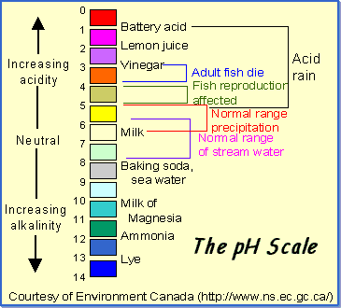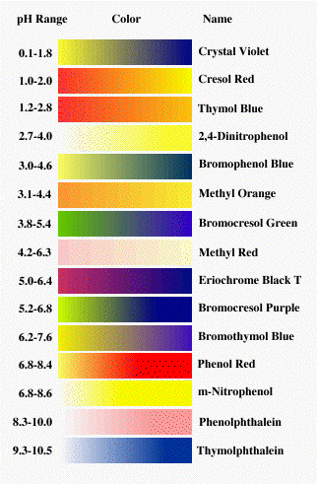
Phenolphthalein and methyl orange are the most common (know for acid-base titrations)

ACID-BASE INDICATORS
Although useful, there are limitations to indicators:
- usually given for a certain temperature (25 oC), thus may change at different temperatures
- what if the solution already has a color, like paint?
- the ability of the human eye to distinguish colors is limited

ACID AND BASE THEORIES
ARRHENIUS DEFINITION (1887)
Acids produce hydrogen ions (H1+) in aqueous solution
(HCl → H1+ + Cl1-)
Bases produce hydroxide ions (OH1-) when dissolved in water.
(NaOH → Na1+ + OH1-)
Limited to aqueous solutions.
Only one kind of base (hydroxides)
NH3 (ammonia) could not be an Arrhenius base: no OH1- produced.

Examples:
Consider HCl = it is an acid!
What about CH4 (methane)?
CH3COOH (ethanoic acid, also called acetic acid) - it has 4 hydrogens just like methane does…?

POLYPROTIC ACIDS
Some compounds have more than one ionizable hydrogen to release
HNO3 nitric acid - monoprotic
H2SO4 sulfuric acid - diprotic - 2 H+
H3PO4 phosphoric acid - triprotic - 3 H+
Having more than one ionizable hydrogen does not mean stronger!

ACIDS
Not all compounds that have hydrogen are acids.
Water?
Also, not all the hydrogen in an acid may be released as ions
only those that have very polar bonds are ionizable - this is when the hydrogen is joined to a very electronegative element

ORGANIC ACIDS (those with Carbon)
Organic acids all contain the carboxyl group, (-COOH), sometimes several of them. CH3COOH – of the 4 hydrogen, only 1 ionizable
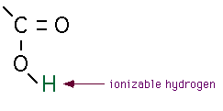
The carboxyl group is a poor proton donor, so ALL organic acids are weak acids.
Always end in COOH

BRØNSTED-LOWRY (1923)
A broader definition than Arrhenius
Acid is hydrogen-ion donor (H+ or proton); base is hydrogen-ion acceptor.
Acids and bases always come in pairs.
HCl is an acid.
When it dissolves in water, it gives it’s proton to water.
HCl(g) + H2O(l) ↔ H3O+(aq) + Cl-(aq)
Water is a base; makes hydronium ion.

Why Ammonia is a Base
Ammonia can be explained as a base by using Brønsted-Lowry:
NH3(aq) + H2O(l) ↔ NH41+(aq) + OH1-(aq)
Ammonia is the hydrogen ion acceptor (base), and water is the hydrogen ion donor (acid).
This causes the OH1- concentration to be greater than in pure water, and the ammonia solution is basic

ACIDS AND BASES COME IN PAIRS
A “conjugate base” is the remainder of the original acid, after it donates it’s hydrogen ion
A “conjugate acid” is the particle formed when the original base gains a hydrogen ion
Thus, a conjugate acid-base pair is related by the loss or gain of a single hydrogen ion.
Chemical Indicators? They are weak acids or bases that have a different color from their original acid and base
HA releases a H, H₂O gains a H

General equation is:
HA(aq) + H2O(l) ↔ H3O+(aq) + A-(aq)
Acid + Base ↔ Conjugate base + Conjugate acid
NH3 + H2O ↔ NH41+ + OH1-
base acid c.a. c.b.
HCl + H2O ↔ H3O1+ + Cl1-
acid base c.a. c.b.
Amphoteric – a substance that can act as both an acid and base- as water shows

LEWIS ACIDS AND BASES
Gilbert Lewis focused on the donation or acceptance of a pair of electrons during a reaction
Lewis Acid - electron pair acceptor
Lewis Base - electron pair donor
Most general of all 3 definitions; acids don’t even need hydrogen!

STRONG OR WEAK
STRENGTH
Acids and Bases are classified according to the degree to which they ionise in water:
Strong are completely ionized in aqueous solution; this means they ionize 100 %
Weak ionize only slightly in aqueous solution
Strength is very different from Concentration

Strong – means it forms many ions when dissolved (100 % ionization)
Mg(OH)2 is a strong base- it falls completely apart (nearly 100% when dissolved).
But, not much dissolves- so it is not concentrated
Ionic dissociate in water, covalent ionise in water

STRONG ACID DISSOCIATION
- makes 100% ions
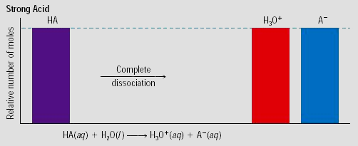

WEAK ACID DISSOCIATION
- only partially ionizes
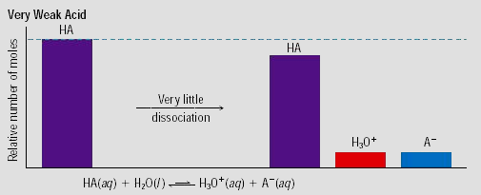

MEASURING STRENGTH
Acids
Ionization is reversible:
HA + H2O ↔ H+ + A-
(note the arrow goes in both directions)
This makes an equilibrium
Acid dissociation constant = Ka
Ka = [H+ ][A- ] / [HA]
(Note that water is NOT shown, because its concentration is constant, and built into Ka)
Stronger acid = more products (ions), thus a larger Ka

Bases
Strong bases dissociate completely.
MOH + H2O ↔ M+ + OH- (M = a metal)
Base dissociation constant = Kb
Kb = [M+ ][OH-] / [MOH]
Stronger base = more dissociated ions are produced, thus a larger Kb.
Weak = higher, strong = lower
Always assume an acid or base is weak unless its one of the strongs

STRENGTH vs CONCENTRATION
The words concentrated and dilute tell how much of an acid or base is dissolved in solution - refers to the number of moles of acid or base in a given volume
The words strong and weak refer to the extent of ionization of an acid or base
Is a concentrated, weak acid possible?

TITRATIONS, SALT HYDROLYSIS AND BUFFERS
TITRATION
The concentration of acid (or base) in solution can be determined by performing a neutralization reaction
An indicator is used to show when neutralization has occurred
Often we use phenolphthalein- because it is colourless in neutral and acid; turns pink in base

STEPS – NEUTRALISATION REACTION
① a measured volume of acid of unknown concentration is added to a flask
② several drops of indicator added
③ a base of known concentration is slowly added, until the indicator changes colour; measure the volume

NEUTRALISATION
The solution of known concentration is called the standard solution
added by using a buret
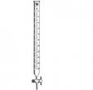
Continue adding until the indicator changes color
called the “end point” of the titration

SALT HYDROLYSIS
Salt produced from an acid-base reaction
A salt is an ionic compound that:
comes from the anion of an acid
comes from the cation of a base
is formed from a neutralization reaction
some neutral; others acidic or basic
“Salt hydrolysis” - a salt that reacts with water to produce an acid or base

Hydrolysing salts usually come from:
a strong acid + a weak base, or
a weak acid + a strong base
Strong refers to the degree of ionisation
A strong Acid + a strong Base = Neutral Salt

To see if the resulting salt is acidic or basic, check the “parent” acid and base that formed it. Practice on these:
HCl + NaOH 🡪 NaCl (a neutral salt)
H2SO4 + NH4OH 🡪 (NH4)2SO4 (acidic salt)
CH3COOH + KOH 🡪 CH₃COOK (basic salt)

NEUTRAL, ACIDIC OR BASIC SALTS
Neutral Salt
Strong Acid + Strong Base
HCl + NaOH 🡪 NaCl + H₂O

Na⁺ + H₂O 🡪 NaOH + H⁺
Cl⁻ + H₂O 🡪 HCl + OH⁻
(neither of these can occur so neutral)

Acidic Salt
Strong Acid + Weak Base
2HNO₃ + Na₂CO₃ 🡪 2NaNO₃ + H₂O + CO₂

CO₂ + H₂O 🡪 H₂CO₃
H₂CO₃ + H₂O 🡪 HCO₃⁻ + H₃O⁺
(only produces H₃O⁺ ions and therefore is acidic)

Basic Salt
Weak Acid + Strong Base
CH₃COOH + Ca(OH)₂ 🡪 Ca(CH₃COO)₂ + H₂O

Ca₂⁺ + 2H₂O 🡪 Ca(OH)₂ + 2H⁺
C₂H₅COO⁻ + H₂O 🡪 CH₃COOH + OH⁻
(top reaction cannot occur, therefore only OH⁻ ions can be produced and therefore is basic)

Neutral Salt
Weak Acid + Weak Base
C₂H₅COOH + NH₃ 🡪 NH₄CH₃COO

NH₄⁺ + H₂O 🡪 NH₃ + H₃O⁺
C₂H₅COO⁻ + H₂O 🡪 C₂H₅COOH + OH⁻

BUFFERS
Usually w.a and salt
Solutions in which the pH remains relatively constant, even when small amounts of acid or base are added
- made from a pair of chemicals, a weak acid and one of it’s salts or a weak base and one of its salts
a buffer system is better able to resist changes in pH than pure water
since it’s a pair of chemicals:
- one chemical neutralizes any acid added, while the other chemical would neutralize any additional base and they produce each other in the process

Buffer capacity
The amount of acid or base that can be added before a significant change in pH
Until it stops working

TITRATION CALCULATIONS
EXAMPLE
Preparing Primary Standard
n(Na₂CO₃) = (0.05)(0.5) = 0.025 mol.

m(Na₂CO₃) = (0.025)(2x22.99 + 12.01 + 48.0) = 2.65g

Primary Standard must:
- be stable
- not react with water
- have a large molecular mass

Standardising HCl
Indicator = Methyl Orange

CO₃²⁻ + 2H⁺ 🡨🡪 H₂O + CO₂

HCl | Trials
 | 1 | 2 | 3 | 4
Volume (mL) | 21.2 | 20.7 | 20.6 | 20.8

n(Na₂CO₃) = (0.05)(0.02) = 0.001 mol.
n(HCl) = 0.002 mol.
2:1 ratio
c(HCl) = 0.002/0.0207 = 0.0966 M
average volume = 0.0207
aliquot = 0.02

Produce 0.1M NaOH
n(NaOH) = (0.1)(0.5) = 0.05 mol.
M(NaOH) = (22.99 + 16.0 + 1.008) = 40.0 g.mol-1
m(NaOH) = 0.05 x 40 = 2 g

2 g of NaOH dissolved in 500 mL of water

Standardising NaOH
Indicator = Phenolphthalein

OH⁻ + H⁺ 🡨🡪 H₂O

NaOH | Trials
 | 1 | 2 | 3 | 4
Volume (mL) | 19.1 | 18.8 | 18.7 | 18.7

n(HCl) = (0.0966)(0.02) = 0.00193 mol.
n(NaOH) = 0.00193 mol.
c(NaOH) = 0.00193/0.01873 = 0.103 M

Concentration of Acetic Acid
Indicator = Phenolphthalien

OH- + CH3COOH 🡨🡪 H2O + CH3COO-

CH₃COOH | Trials
 | 1 | 2 | 3 | 4
Volume (mL) | 21.5 | 21.2 | 21.0 | 21.3

n(NaOH) = (0.103)(0.02) = 0.00206 mol.
n(CH₃COOH) = 0.00206 mol.
c(CH₃COOH)_{Dilute} = 0.00206/0.0212 = 0.0974 M
c(CH₃COOH)_{Conc.} = (10)(0.0974) = 0.974 M

% of Acetic Acid in Vinegar
n(CH₃COOH)_{1000mL} = 0.974 mol.
M(CH₃COOH) = 2x12.01 + 4x1.008 + 2x16.0 = 60.052 g.mol.-1
m(CH₃COOH)_{1000mL} = (0.974)(60.052) = 58.5 g
m(Vinegar)_{1000mL} = 1050 g
%(Acetic Acid) = (58.5/1050)x100 = 5.6%

REDOX

OXIDATION – REDUCTION
Oxidation and reduction always occur simultaneously

The substance gaining oxygen (or losing electrons) is oxidized, while the substance losing oxygen (or gaining electrons) is reduced.

Redox currently says that electrons are transferred between reactants

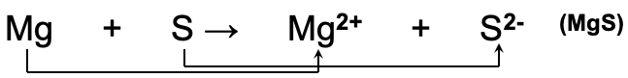
The magnesium atom (which has zero charge) changes to a magnesium ion by losing 2 electrons, and is oxidized to Mg2+
The sulfur atom (which has no charge) is changed to a sulfide ion by gaining 2 electrons, and is reduced to S2-

2Na⁽⁰⁾ + Cl₂⁽⁰⁾ 🡪 2Na⁽⁺¹⁾Cl⁽⁻¹⁾

Each sodium atom loses one electron:
Na⁽⁰⁾ 🡪 Na⁽⁺¹⁾ + e⁻

Each chlorine atom gains one electron:
Cl⁽⁰⁾ + e⁻ 🡪 Cl⁽⁻¹⁾

LEO SAYS GER
Lose Electrons = Oxidation
Na⁽⁰⁾ 🡪 Na⁽⁺¹⁾ + e⁻

Gain Electrons = Reduction
Cl⁽⁰⁾ + e⁻ 🡪 Cl⁽⁻¹⁾

- Losing electrons is oxidation, and the substance that loses the electrons is called the reducing agent
- Gaining electrons is reduction, and the substance that gains the electrons is called the oxidizing agent

Mg_{(s)} + S_{(s)} 🡪 MgS_{(s)}
Mg is oxidised (loses electrons) = reducing agent
S is reduced (gains electrons) = oxidising agent

NOT ALL REACTIONS ARE REDOX REACTIONS
- Reactions in which there has been no change in oxidation number are NOT redox reactions
Examples:
Ag⁽⁺¹⁾N⁽⁺⁵⁾O₃⁽⁻²⁾_{(aq)} + Na⁽⁺¹⁾Cl⁽⁻¹⁾_{(aq)} 🡪 Ag⁽⁺¹⁾Cl⁽⁻¹⁾_{(s)} + Na⁽⁺¹⁾N⁽⁺⁵⁾O₃⁽⁻²⁾_{(aq)}
2Na⁽⁺¹⁾O⁽⁻²⁾H⁽⁺¹⁾_{(aq)} + H₂⁽⁺¹⁾S⁽⁺⁶⁾O₄⁽⁻²⁾_{(aq)} 🡪 Na₂⁽⁺¹⁾S⁽⁺⁶⁾O₄⁽⁻²⁾_{(aq)} + H₂⁽⁺¹⁾O⁽⁻²⁾_{(l)}

CORROSION
Damage done to metal is costly to prevent and repair
Iron, a common construction metal often used in forming steel alloys, corrodes by being oxidized to ions of iron by oxygen.
This corrosion is even faster in the presence of salts and acids, because these materials make electrically conductive solutions that make electron transfer easy

Luckily, not all metals corrode easily
Gold and platinum are called noble metals because they are resistant to losing their electrons by corrosion
Other metals may lose their electrons easily, but are protected from corrosion by the oxide coating on their surface, such as aluminum.
Iron has an oxide coating, but it is not tightly packed, so water and air can penetrate it easily

Serious problems can result if bridges, storage tanks, or hulls of ships corrode
Can be prevented by a coating of oil, paint, plastic, or another metal
If this surface is scratched or worn away, the protection is lost
Other methods of prevention involve the “sacrifice” of one metal to save the second
Magnesium, chromium, or even zinc (called galvanized) coatings can be applied

OXIDATION NUMBER
ASSIGNING OXIDATION NUMBERS
An “oxidation number” is a positive or negative number assigned to an atom to indicate its degree of oxidation or reduction.
Generally, a bonded atom’s oxidation number is the charge it would have if the electrons in the bond were assigned to the atom of the more electronegative element

RULES FOR ASSIGNING OXIDATION NUMBERS
① An uncombined element = 0
Because even distribution of electrons
② Monatomic ion = its charge
③ Oxygen in compounds = -2, Oxygen in peroxides (e.g. H₂O₂) = -1
④ Hydrogen in compounds = +1, Metal hydrides (e.g. NaH) = -1
⑤ The sum of oxidation numbers of the atoms in a compound must = 0
⑥ The sum of oxidation numbers in a formula of a polyatomic ion = its ionic charge

An increase in oxidation number = oxidation
A decrease in oxidation number = reduction

REDOX EQUATIONS
TRENDS IN OXIDATION AND REDUCTION
Active metals:
Group 1 and 2
- Lose electrons easily
- Are easily oxidized
- Are strong reducing agents

Active nonmetals:
Group 16+17
- Gain electrons easily
- Are easily reduced
- Are strong oxidising agents

IDENTIFYING REDOX EQUATIONS
In general, all chemical reactions can be assigned to one of two classes:
- oxidation-reduction, in which electrons are transferred:
- Single-replacement, combination, decomposition, and combustion
- this second class has no electron transfer, and includes all others:
- Double-replacement and acid-base reactions

In an electrical storm, nitrogen and oxygen react to form nitrogen monoxide:
N2(g) + O2(g) → 2NO(g)
Is this a redox reaction? (YES)
If the oxidation number of an element in a reacting species changes, then that element has undergone either oxidation or reduction; therefore, the reaction as a whole must be a redox.

BALANCING REDOX EQUATIONS
It is essential to write a correctly balanced equation that represents what happens in a chemical reaction
Fortunately, two systematic methods are available, and are based on the fact that the total electrons gained in reduction equals the total lost in oxidation. The two methods:
- Use oxidation-number changes
- Use half-reactions

USING OXIDATION-NUMBER CHANGES
Sort of like chemical bookkeeping, you compare the increases and decreases in oxidation numbers.
start with the skeleton equation
① assign oxidation numbers to all atoms; write above their symbols
② identify which are oxidized/reduced
③ use bracket lines to connect them
④ use coefficients to equalize
⑤ make sure they are balanced for both atoms and charge

USING HALF-REACTIONS
A half-reaction is an equation showing just the oxidation or just the reduction that takes place
they are then balanced separately, and finally combined
① write unbalanced equation in ionic form
② write separate half-reaction equations for oxidation and reduction
③ balance the atoms in the half-reactions
④ add enough electrons to one side of each half-reaction to balance the charges
⑤ multiply each half-reaction by a number to make the electrons equal in both
⑥ add the balanced half-reactions to show an overall equation
⑦ add the spectator ions and balance the equation
Only do step 7 if asker to include spectator ions

CHOOSING A BALANCING METHOD
- The oxidation number change method works well if the oxidized and reduced species appear only once on each side of the equation, and there are no acids or bases.
- The half-reaction method works best for reactions taking place in acidic or alkaline solution.

GALVANIC CELLS
ELECTRON TRANSFER REACTIONS
- Electron transfer reactions are oxidation-reduction or redox reactions.
- Results in the generation of an electric current (electricity).
- Therefore, this field of chemistry is often called electrochemistry

Electrochemical processes are oxidation-reduction reactions in which:
the energy released by a spontaneous reaction is converted to electricity

2Mg⁽⁰⁾_{(s)} + O₂⁽⁰⁾_{(g)} 🡪 2Mg⁽⁺²⁾O⁽⁻²⁾_{(s)}
2Mg 🡪 2Mg⁽⁺²⁾ + 4e⁻ (oxidation ½ reaction – lose e⁻)
O₂ + 4e⁻ 🡪 2O²⁻ (reduction ½ reaction – gain e⁻)

- Reduction cannot happen without an oxidation to provide the electrons
- You can’t have 2 oxidations or 2 reductions in the same equation. Reduction has to occur at the cost of oxidation

BALANDING REDOX EQUATIONS
① unbalanced equation
② half reactions
③ balance atoms other than O and H
④ balance O with H₂O
⑤ balance H with H⁺
⑥ balance charges with e⁻
⑦ balance the half reactions (multiplying by other electron numbers)

CHEMICAL CHANGE 🡪 ELECTRIC CURRENT
To obtain a useful current, we separate the oxidizing and reducing agents so that electron transfer occurs thru an external wire
- This is accomplished in a galvanic or voltaic cell
- A group of cells is called a battery

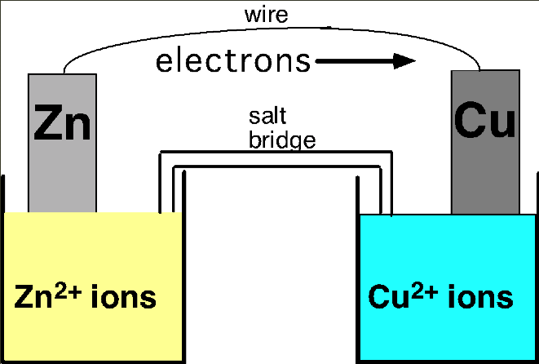

GALVANIC CELLS
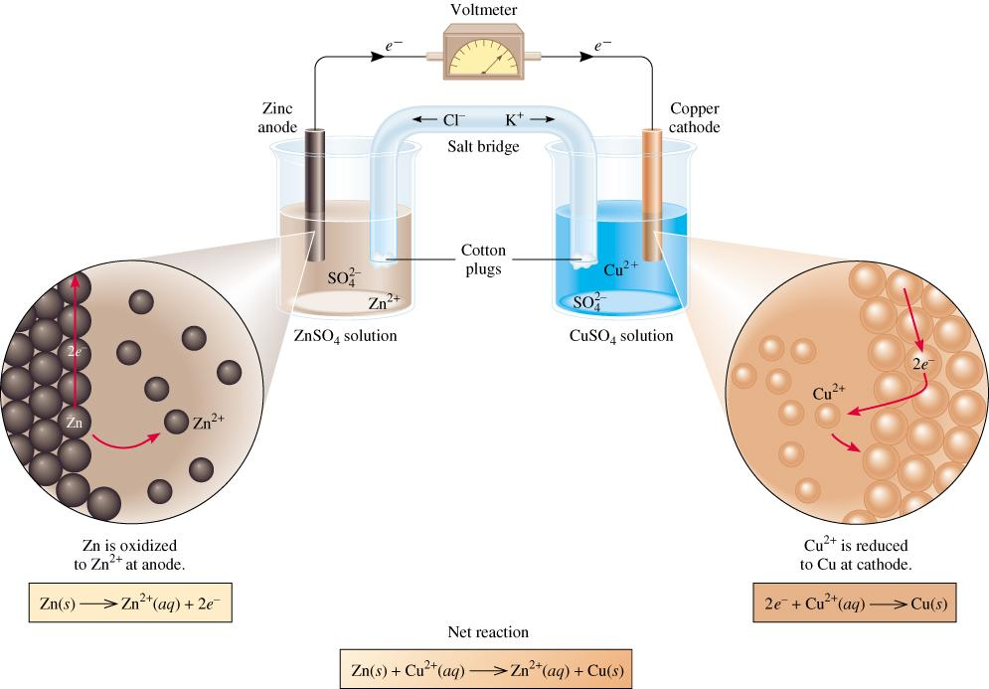
Most reactive = Zn (metals -> therefore lose electrons) therefore most reactive are likely to oxidise (look from the bottom up on the data sheet)

Anode = breaking down, cathode = building up

Oxidation anode

On the zinc side, more and more positives are made = harder to get electrons to leave

Furthest down on data sheet = more reactive = more likely to be part of an ionic substance

The difference in electrical potential between the anode and cathode is called:
- cell voltage
- electromotive force (emf)
- cell potential

Zn_{(s)} + Cu²⁺_{(aq)} 🡪 Cu_{(s)} + Zn²⁺_{(aq)}
[Cu²⁺] = 1 M and [Zn²⁺] = 1 M
Zn is more reactive = lose electrons more easily
Always 1M different means you don’t have to do calculations
<1M, v = lower
>1M, v = higher

STANDARD ELECTRODE POTENTIALS
Standard reduction potential (E⁰) is the voltage associated with a reduction reaction at an electrode when all solutes are 1 M and all gases are at 1 atm.
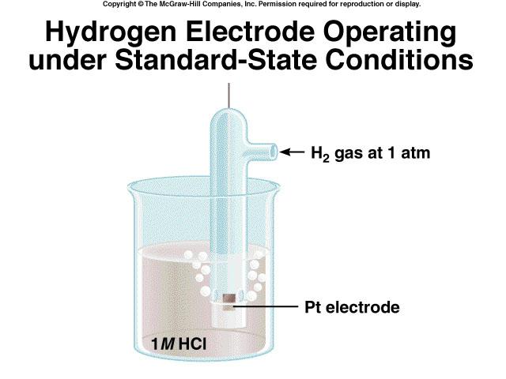 Standard Hydrogen electrode (SHE)
Reduction reaction
2e⁻ + 2H⁺ (1 M) 🡪 H₂ (1 atm)
E⁰ = 0 V
Reference cell = hydrogen cell

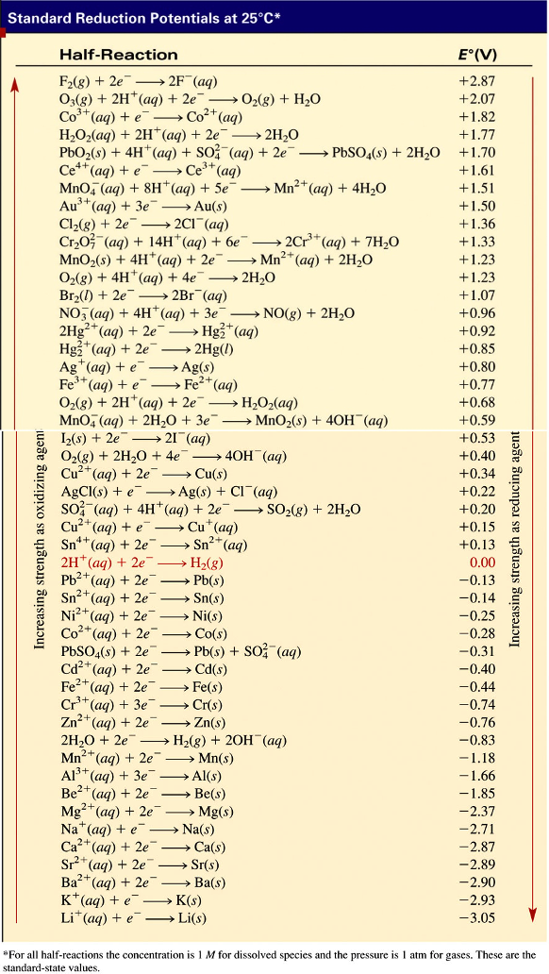
- E⁰ is for the reaction as written
- The more positive E⁰ the greater the tendency for the substance to be reduced
- The half-cell reactions are reversible
- The sign of E⁰ changes when the reaction is reversed
- Changing the stoichiometric coefficients of a half-cell reaction does not change the value of E⁰

STANDARD ELECTRODE POTENTIALS
Standard EMF (E⁰_{cell})

E⁰_{cell} = E⁰_{cathode} + E⁰_{anode}

Example
What is the standard emf of an electrochemical cell made of a Cd electrode in a 1.0 M Cd(NO3)2 solution and a Cr electrode in a 1.0 M Cr(NO3)3 solution?

Cd²⁺_{(aq)} + 2e⁻ 🡪 Cd_{(s)} E⁰ = -0.40 V
Cr³⁺_{(aq)} + 3e⁻ 🡪 Cr_{(s)} E⁰ = -0.74 V

Cd is the stronger oxidizer
Cd will oxidise Cr

Anode (oxidation): Cr_{(s)} 🡪 Cr³⁺ (1 M) + 3e⁻
Cathode (reduction): 2e⁻ + Cd²⁺ (1 M) 🡪 Cd_{(s)}

2Cr_{(s)} + 3Cd²⁺ (1 M) 🡪 3Cd_{(s)} + 2Cr³⁺ (1 M)

E⁰_{cell} = E⁰_{cathode} + E⁰_{anode}
E⁰_{cell} = -0.40 + (+0.74)
E⁰_{cell} = 0.34V

Steps:
① ½ equations
② balance
③ E⁰ for each
④ flip
⑤ add = E⁰
Negative E⁰ + E⁰ = not possible
Positive number = spontaneous reaction

OTHER CELLS AND ELECTROLYSIS
CHARGING A BATTERY
When you charge a battery (containing secondary cells), you are forcing the electrons backwards (from the + to the -). To do this, you will need a higher voltage backwards than forwards. This is why the ammeter in your car often goes slightly higher while your battery is charging, and then returns to normal.
In your car, the battery charger is called an alternator. If you have a dead battery, it could be the battery needs to be replaced OR the alternator is not charging the battery properly.

BATTERIES
Dry cell (Leclanché cell)
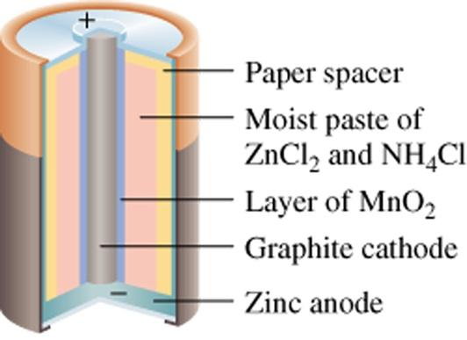

Anode: Zn_{(s)} 🡪 Zn²⁺_{(aq)} + 2e⁻
Cathode: 2NH_{4(aq)} + 2MnO_{2(s)} + 2e⁻ 🡪 Mn₂O_{3(s)} + 2NH_{3(aq)} + H₂O_{(l)}
Overall reaction: Zn_{(s)} + 2NH_{4(aq)} + 2MnO_{2(s)} 🡪 Zn²⁺_{(aq)} + 2NH_{3(aq)} + H₂O_{(l)} + Mn₂O_{3(s)}

Salt bridge:
- Ionic
- KNO₃⁻ is best (cannot form a precipitate)

Mercury Battery
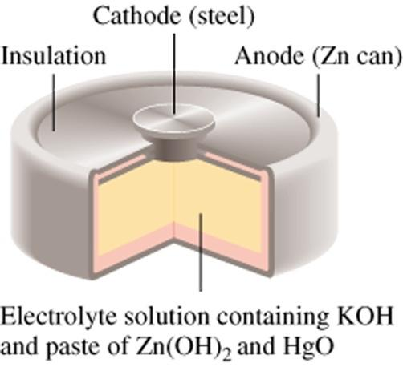

Anode: Zn(Hg) + 2OH⁻_{(aq)} 🡪 ZnO_{(s)} + H₂O_{(l)} + 2e⁻
Cathode: HgO_{(s)} + H₂O_{(l)} + 2e⁻ 🡪 Hg_{(l)} + 2OH⁻_{(aq)}
Overall reaction: Zn(Hg) + HgO_{(s)} 🡪 ZnO_{(s)} + Hg_{(l)}

Lead Storage Battery
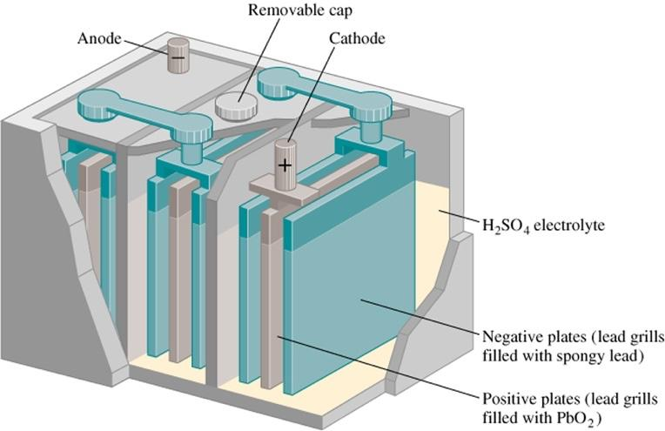
Anode: Pb_{(s)} + SO²⁻_{(aq)} 🡪 PbSO_{4(s)} + 2e⁻
Cathode: PbO_{2(s)} + 4H⁺_{(aq)} + SO²⁻_{(aq)} + 2e⁻ 🡪PbSO_{4(s)} + 2H₂O_{(l)}
Overall reaction: Pb_{(s)} + PbO_{2(s)} + 4H⁺_{(aq)} + 2SO²⁻_{(aq)} 🡪 2PbSO_{4(s)} + 2H₂O_{(l)}

Solid State Lithium Battery
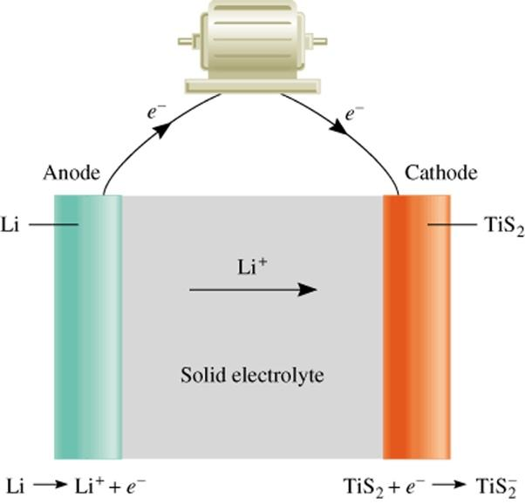

FUEL CELLS
- An electrochemical cell that requires a continuous supply of reactants to keep functioning
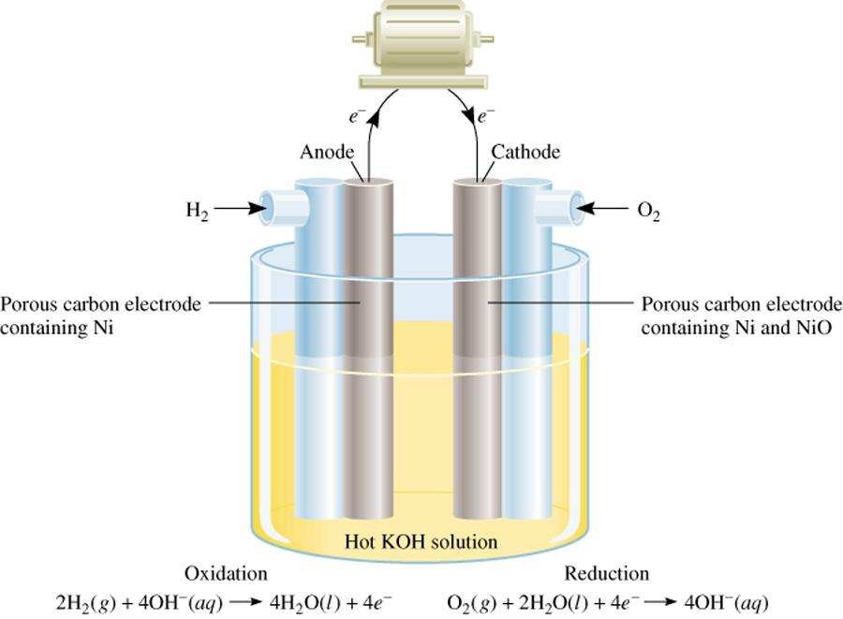
Anode: 2H_{2(g)} + 4OH⁻_{(aq)} 🡪 4H₂O_{(l)} + 4e⁻
Cathode: O_{2(g)} + 2H₂O_{(l)} + 4e⁻ 🡪 4OH⁻_{(aq)}
Overall reaction: 2H_{2(g)} + O_{2(g)} 🡪 2H₂O_{(l)}

CORROSION
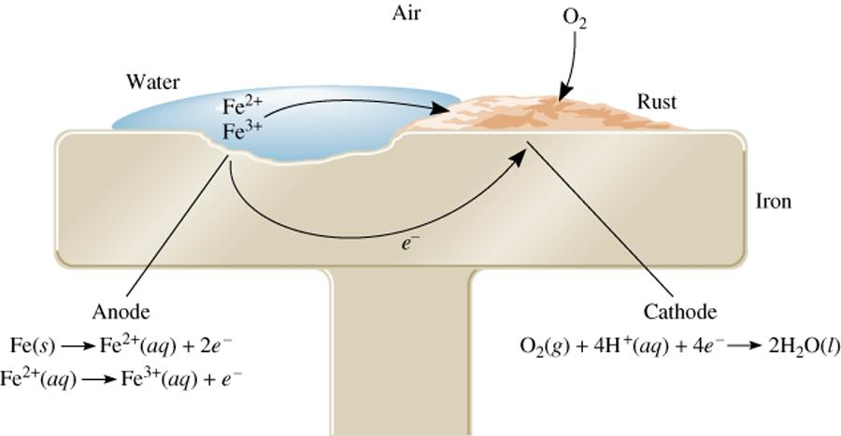

Cathodic Protection of an Iron Storage Tank
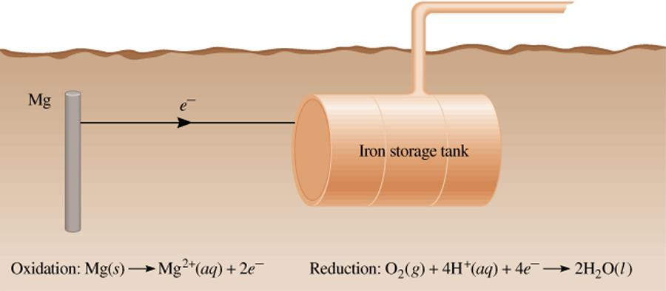

ELECTROLYSIS
- the process in which electrical energy is used to cause a nonspontaneous chemical reaction to occur
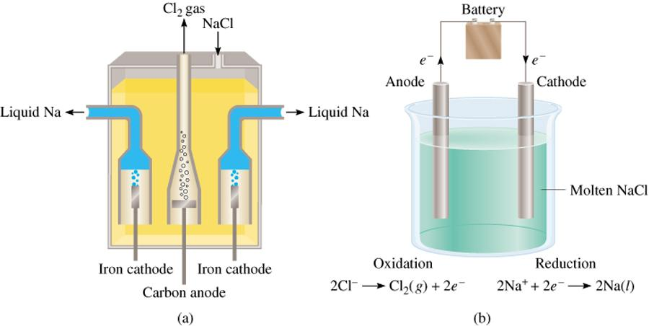

Electrolysis of Water
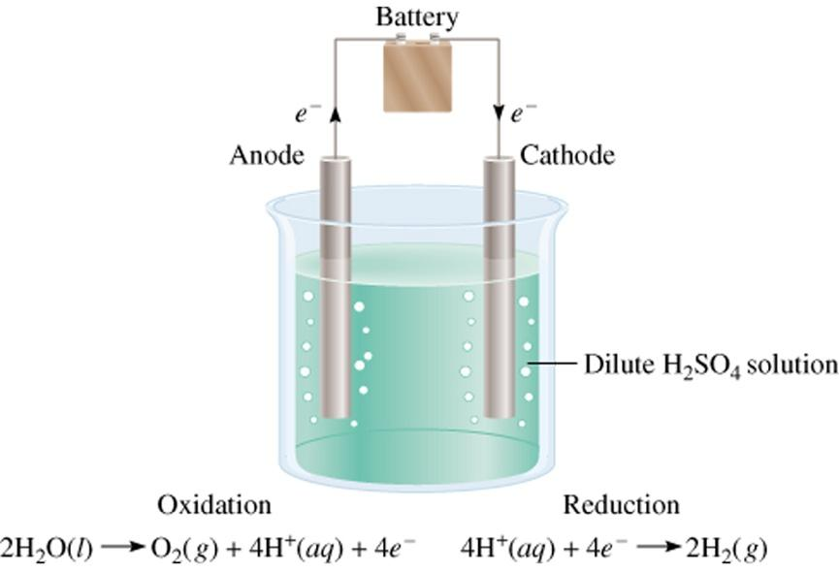

ORGANIC CHEMISTRY

Y11 REVISION AND FUNCTIONAL GROUPS
Y11 REVISION
Alkanes
- general formulae
  - C_{n}H_{2n+2}
- nomenclature
- properties
- reactions
  - substitution
  - combustion

Alkenes
- general formulae
  - C₂H_{2n}
- nomenclature
- properties
- reactions
  - combustion
  - addition
- isomers (including geometric)
  - same formula, different arrangement (e.g. butane, 2-methylpropane)
  - if double bond is in first = not geometric

Benzene
- general formulae
  - C₆
- nomenclature
- properties
  - strong 3 double bonds, 3 single bonds move (delocalised electrons can shift)
  - least reactive

FUNCTION GROUPS (CONSTITUENTS)
- The physical and chemical properties of organic chemicals depend mainly on the “groups “ attached to the main hydrocarbon chain.

Red = oxygen
H = hydrogen
C = carbon

Alcohols
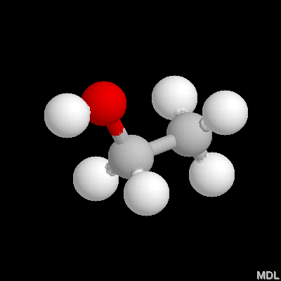
- OH at the end
- Has a hydroxyl group (OH)

Carboxylic Acids
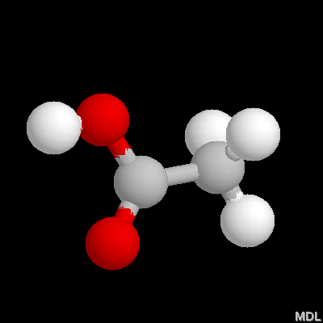
- Organic acid COOH @ end
- Has a hydroxyl group (the COOH)

Aldehyde
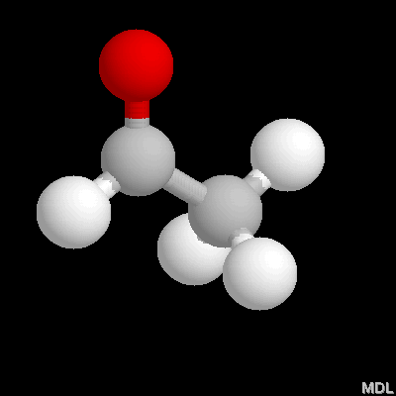
- Carbon chain with double bonded O at the end

Ketones
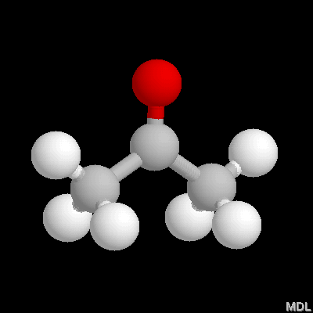
- Double bonded O in the middle

acet- = minimum number of C in chain

Esters
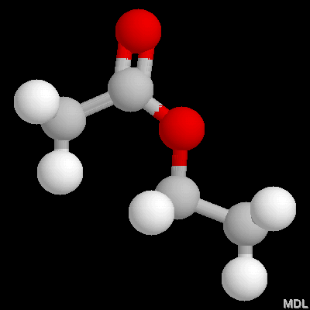
- From reaction of alcohol and carboxylic acid
- 2 carbon chains connected by O
- Aromatics
- One has a double bonded O connected

Amines
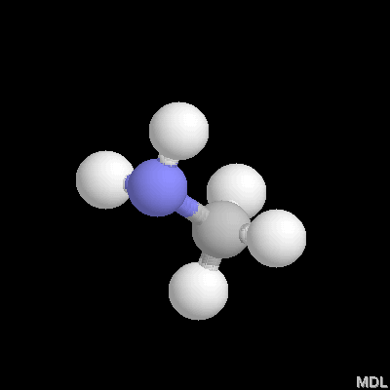
- Related to ammonia
- N and 2H’s

Amides
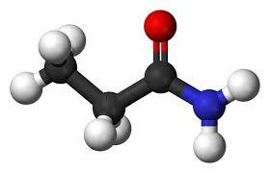
- Double bonded O

Proteins = amino acids, acid group and amine group
If last C has H’s = amine
If last C has an O double bonded = amide

ALCOHOLS
ALCOHOLS (R-OH)
Atomic grouping | -OH
Suffix | -ol
Prefix | hydroxy
Position in chain | anywhere
General formula | C_{n}H_{2n+2}O
Common family name | alcohols

FORMATION OF ALCOHOL
- Fermentation of sugars
- Addition of H₂O to alkenes (using steam, with catalyst)
  - E.g. CH₃CH=CH₂ + H₂O 🡪 CH₃CHOHCH₃
propene + water 🡪 2-propanol

TYPES OF ALCOHOL
- Primary – (1º): -OH attached to a C with just one other attached C
  - E.g. CH₃CH₂OH
- Secondary – (2º): -OH attached to a C with two other attached C’s
  - E.g. 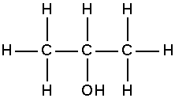
- Tertiary – (3º): -OH attached to a C with three other attached C’s
  - E.g. 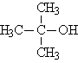

NOMENCLATURE
- Choose the longest chain containing the –OH
- Number chain to give –OH the lowest number
- Suffix “ol” is used to denote and alcohol, number before the ’ol’ or before the alkane name
  - E.g. 2-propanol OR propan-2-ol
- Use prefix ‘hydroxy’ if multiple functional groups,
  - E.g. 3-hydroxypentanoic acid

REACTIONS OF ALCOHOLS
- Reactive metals:
  - Alcohols can react in a similar way to water or acids with reactive metals
  - 2R-OH_{(l)} + 2Na_{(s)} 🡪 H₂ + 2R-O⁻_{(aq)} + 2Na⁺_{(aq)}
  - 2CH₃OH_{(l)} + 2Na_{(s)} 🡪 H_{2(g)} + 2NaCH₃O_{(aq)}
  - Products - hydrogen gas and metal alkoxide
  - Reactivity decreases with chain length
  - Reactivity decreases 1º>2º>3º

Products of complete combustion = H₂O + CO₂
Products of incomplete combustion = CO + C
Alcohol + active metal 🡪 H₂ + salt

Oxidation
- In the presence of strong oxidising agents (MnO₄⁻, Cr₂O₇²⁻), Alcohols can be oxidised by dehydrogenation (loss of hydrogen)
- 1° Alcohols are oxidised to aldehydes
- Aldehydes if not isolated will further oxidise to form carboxylic acids
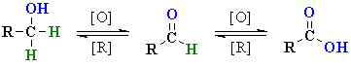
Example 1 – Oxidation
CH₃ CH₂OH_{(l)} 🡪 CH₃CHO_{(aq)}
MnO₄⁻_{(aq)} 🡪 Mn²⁺_{(aq)}

Example 2 – Oxidation
CH₃CH₂OH_{(l)} 🡪 CH₃COOH_{(aq)}
MnO₄⁻_{(aq)} 🡪 Mn²⁺_{(aq)}

- 2° Alcohols when oxidised by strong oxidising agents produce ketones.
- Ketones are not readily susceptible to further oxidation
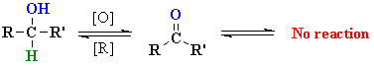

Example 3 – Oxidation
CH₃CHOHCH₃ _{(aq)} 🡪 CH₃COCH₃ _{(aq)}
Cr₂O₇²⁻_{(aq)} 🡪 Cr³⁺_{(aq)}

3° Alcohol 🡪 No Reaction
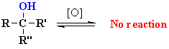 (no hydrogen to lose)

Reactivity: 1º>2º>3º (N.R.)
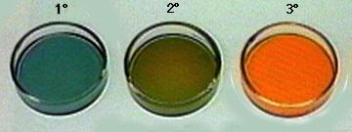

OTHER ORGANIC COMPOUNDS
Aldehydes, Ketones, Carbonic Acids, Esters, Amines and Amides

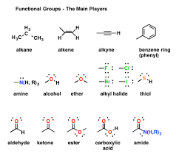

ALDEHYDES
- Formed by dehydrogenation of alcohols
- Formed from 1º alcohols
- End in -CHO
- Suffix –al
- Must be on the end of a carbon chain
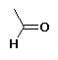

KETONES
- Contain a “double bonded ‘O’” on a secondary carbon
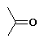
- Suffix –one,
- Formed by oxidation of 2º Alcohols
- Usually needs to be numbered, eg
  - 2-pentanone, or pentan-2-one
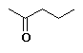

CARBOXYLIC ACIDS
- end in –COOH
- Suffix- -oic acid
- Numbers not necessary
- Hydrogen Bonding
- Weak acids (H⁺ partially ionises)
- Acidity decreases with chain length
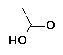
Longer chain = less acidic

ESTERS
- Formed by reaction of a Carboxylic acid with an alcohol
- Structure: RCOOR’
- -H from acid replaced with Alkyl group from alcohol
- Named Alkyl Alkanoate, eg Ethyl Propanoate where propanoate comes from the Acid.


AMINES
Atomic grouping | -NH₂
Suffix | -amine
Prefix | Amino
Position in chain | Anywhere
General formula | C_{n}H_{2n+3}N


AMIDES
Atomic grouping | 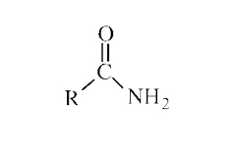
Suffix | -amide
Prefix | Carbamoyl
Position in chain | Anywhere
General Formula | C_{n}H_{2n+1}NO

PROPERTIES
Compound | MP/BP | Soluble in water? | Solvent for?
Alkanes | Low | No | Non-polar
Alkenes | Low | No | Non-polar
Alcohols | High | Yes | Polar
Aldehydes | High | Yes | Polar
Ketones | High | Yes | Polar
Carboxylic Acids | High | Yes | Polar
Amines | High | Yes | Polar
Amides | High | Yes | Polar

Alkanes dissolve non-polar because they are non-polar
Like dissolves like
Non-polar are held by dispersion forces and alkanes can disrupt the IMF (dispersion forces)

POLYMERS + PLASTICS
ELEMENTS IN POLYMERS
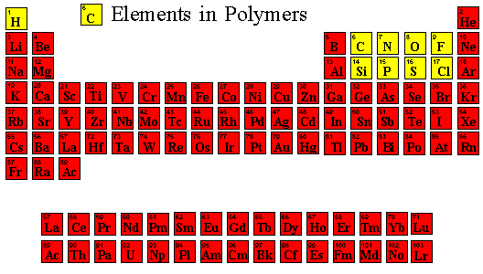

Monomer: a small molecule which may react chemically to link together with other molecules of the same type to form a large molecule called a polymer

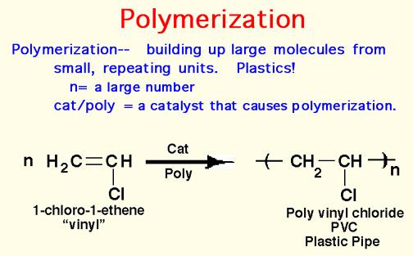

Example 1
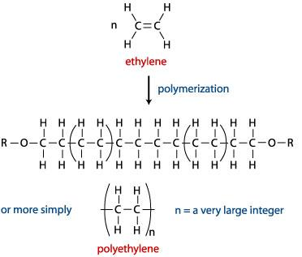

Example 2
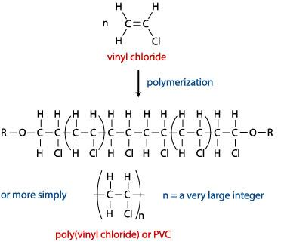

ADDITION POLYMERISATION ANIMATION


CONDENSTION POLYMERISATION
n Dicarboxylic Acid + n Diol(or Diamine) 🡪 Polymer + 2n H₂O
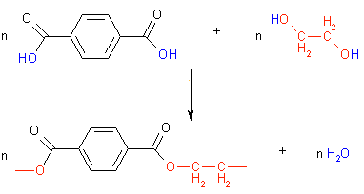
(The reactions involved in the synthesis of PET)

CONDENSATION POLYMERISATION ANIMATION


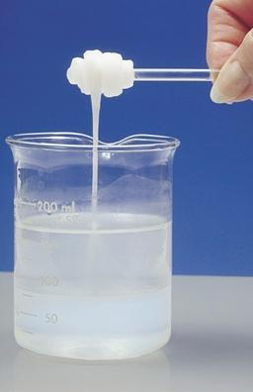 Nylon production

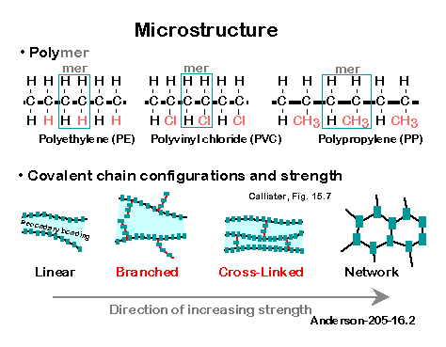

SOAPS AND PROTEINS

SOAPS + DETERGENTS
SOAPS
- Soaps are the sodium and potassium salts of the long chain Fatty acid. A soap molecule consists of a long hydrocarbon chain (composed of carbons and hydrogen) with a carboxylic acid on one end which is ionic bonded to metal ion usually a sodium or potassium.
- A soap has a large non-ionic hydrocarbon group and an ionic group COO-Na+.

EXAMPLES OF SOAPS
- Sodium stearate
- (Chemical formula: C₁₇H₃₅COO⁻Na⁺)
- Sodium palmitate
- (Chemical formula: C₁₅H₃₁COO⁻Na⁺)
- Sodium oleate
- (Chemical formula: C₁₇H₃₃COO⁻Na⁺)

SAPONIFICATION
- The process of making soap by the hydrolysis of fats and oils with alkalies is called saponification.
- Soap is made by heating animal fats or vegetable oil with concentrated sodium hydroxide (NaOH).
- Fat or Oil + NaOH → Soap + Glycerol

EXAMPLE OF SAPONIFICATION
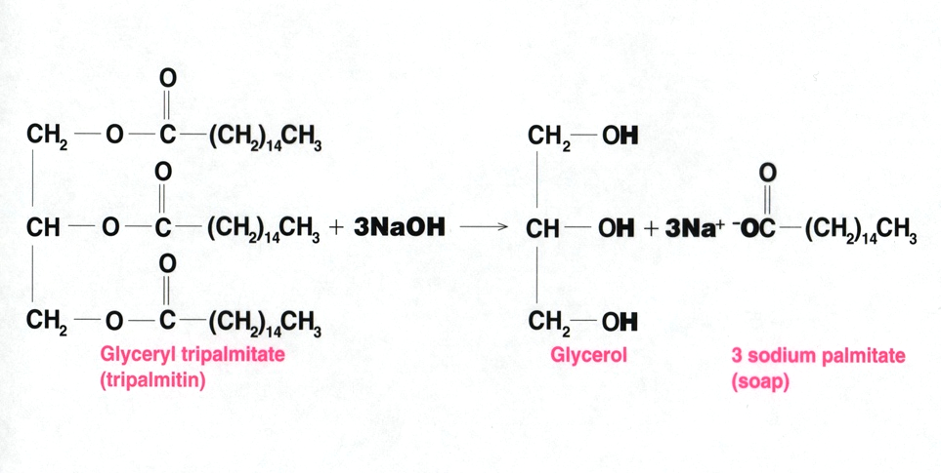
Glyceryl tripalmitate (tripalmitin) 🡪 Glycerol + 3-sodium palmitate (soap)

MICELLES – SOAP MOLECULES
A soap molecule has two ends with different properties-
1. A long hydrocarbon part (R) which is hydrophobic (i.e. it dissolves in hydrocarbon or oils or dirts).
2. A short ionic part containing COO-Na+ which is hydrophilic (i.e. it dissolves in water).
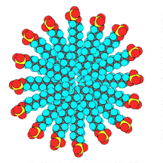

WORKING OF MICELLES
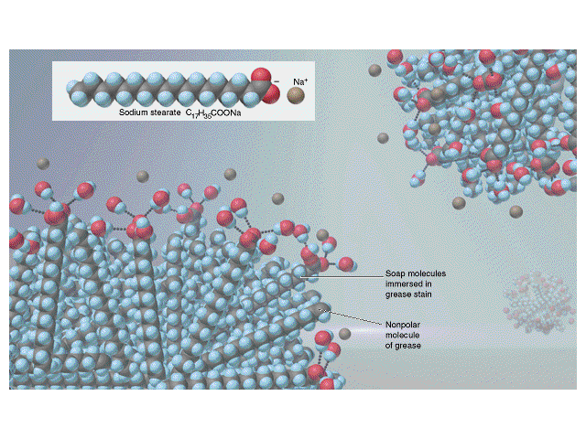

MECHANISM OF CLEANING ACTION OF SOAPS
When a dirty cloth is put in water containing soap than the hydrocarbon ends of the soap molecule in the micelle attach to the oil or grease particles present on the surface of dirty cloth. In this way the soap micelles entraps the oily particles by using the hydrocarbon ends. The ionic ends of the soap molecules remain attached to the water when the dirty cloth is agitated in soap solution. The oily particles presents on its surface gets dispersed in the water due to which the cloth gets clean.

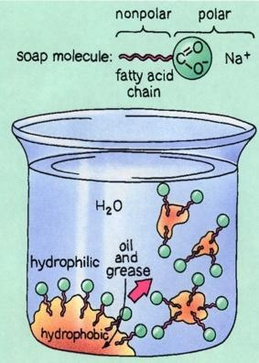

Advantages | Disadvantages
- Soaps are eco-friendly and biodegradable | - Soaps are not suitable in the hard water  - They have weak cleansing properties than detergents  - 2C₁₇H₃₅COO⁻_{(aq)} + Ca ²⁺_{(aq)}  - Ca(C₁₇H₃₅COO)2_{(s)} (Insoluble salt of Calcium)

DETERGENTS OF SYNDETS
- The term detergent is now generally used for synthetic soap-like cleansing agents which are also referred to as Syndets.

DETERGENTS
- Detergents are the sodium salts of long chain benzene sulphuric acids.
- Detergents are primarily surfactants. Surfactants lower the surface tension of water, essentially making it 'wetter' so that it is less likely to stick to itself and more likely to interact with oil and grease.
- The ionic group is in a detergent is
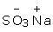

EXAMPLES OF DETERGENTS
- Two basic examples of well-known detergents of the sulphonate group or the sulphate group are:
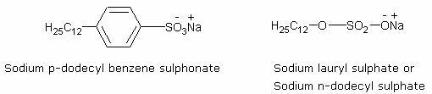

Sodium Lauryl Sulphonate, CH₃(CHs)1₀CH2—O—SO3 Na
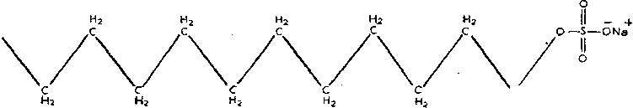

Sodium n-dodecylbenzene sulphonate, P-CH₃(CH₂)_{U}—C₆H₄—SO3Na
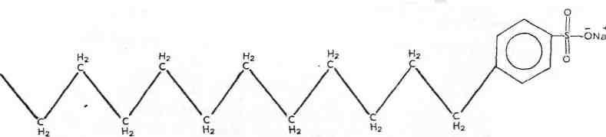

CLEANSING ACTION OF DETERGENTS
- Synthetic detergents have the same type of molecular structure as soaps i.e. a tadpole like molecule having two parts at each end i.e., one large non-polar hydrocarbon group that is water repelling (hydrophobic) and one short ionic group usually containing the or group that is water attracting (hydrophilic).
- Thus the cleansing action is exactly similar to that of soaps whereby the formation of micelles followed by emulsification occurs.
- However, synthetic detergents can lather well even in hard water.
- This is because they are soluble sodium or potassium salts of sulphonic acid or alkyl hydrogen sulphate and similarly form soluble calcium or magnesium salts on reacting with the calcium ions or magnesium ions present in water.
- This is a major advantage of the cleansing property of detergents over soap.

DISADVANTAGES OF DETERGENTS
- Many detergents are resistant to the action of biological agents and thus are not biodegradable. Their elimination from municipal wastewaters by the usual treatments is a problem.
- They have a tendency to produce stable foams in rivers that extend over several hundred meters of the river water. This is due to the effects of surfactants used in their preparation. Thus, they pose a danger to aquatic life.
- They tend to inhibit oxidation of organic substances present in wastewaters because they form a sort of envelope around them.

DIFFERENCES BETWEEN SOAPS AND DETERGENTS
Soaps | Detergents
- They are metal salts of long chain higher fatty acids.  - These are prepared from vegetable oils and animal fats.  - They cannot be used effectively in hard water as they produce scum i.e., insoluble precipitates of Ca2+, Mg2+, Fe2+ etc. | - These are sodium salts of long chain hydrocarbons like alkyl sulphates or alkyl benzene sulphonates.  - They are prepared from hydrocarbons of petroleum or coal.  - These do not produce insoluble precipitates in hard water. They are effective in soft, hard or salt water.

PROTEINS
TYPES OF PROTEINS
Proteins perform essential functions throughout the systems of the human body. These long chains of amino acids are critically important for:
- catalyzing chemical reactions
- synthesizing and repairing DNA
- transporting materials across the cell
- receiving and sending chemical signals
- responding to stimuli
- providing structural support

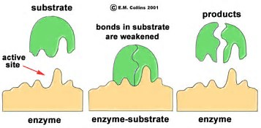

FUNCTION OF PROTEINS
Proteins (a polymer) are macromolecules composed of amino acid subunits (the monomers). These amino acids are covalently attached to one another to form long linear chains called polypeptides, which then fold into a specific three-dimensional shape. Sometimes these folded polypeptide chains are functional by themselves. Other times they combine with additional polypeptide chains to form the final protein structure. Sometimes non-polypeptide groups are also required in the final protein. For instance, the blood protein hemoglobin is made up of four polypeptide chains, each of which also contains a heme molecule, which is a ring structure with an iron atom in its center.
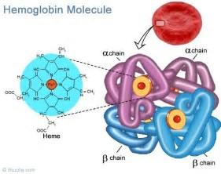

PRIMARY STRUCTURE
The primary structure is determined by the sequence of amino acids present in the protein.
Amino acids are comprised of a functional group R attached to an amine group (NH₂) and a carboxyl group (COOH).
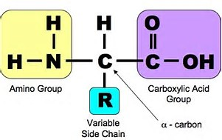
α = amino acid

R GROUPS
- Non-polar R groups
- Polar R groups that form ions
- Polar R groups that do not form ions

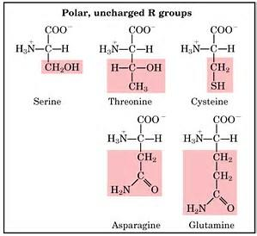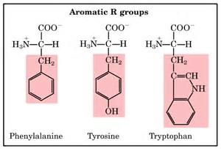
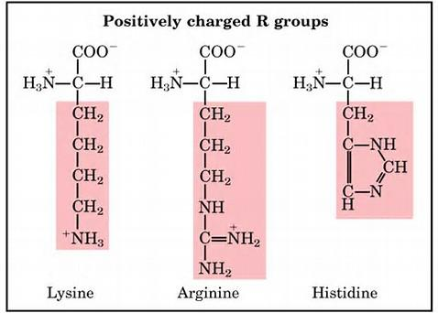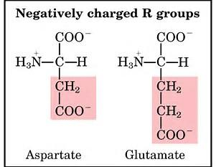

ZWITTERION
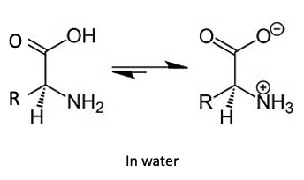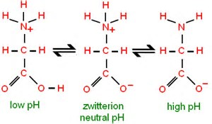

CONDENSATION POLYMERISATION OF AMINO ACIDS


SECONDARY STRUCTURE
The structure is determined by the way the amino acids are bonded together. Folding and twisting as a result of Hydrogen bonds.
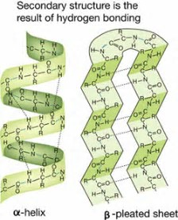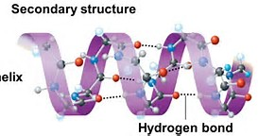

TERTIARY AND QUATERNARY STRUCTURE
The overall three-dimensional shape of an entire protein molecule is the tertiary structure. The protein molecule will bend and twist in such a way as to achieve maximum stability or lowest energy state. Although the three-dimensional shape of a protein may seem irregular and random, it is fashioned by many stabilizing forces due to bonding interactions between the side-chain groups of the amino acids.
Many proteins are made up of multiple polypeptide chains, often referred to as protein subunits. These subunits may be the same (as in a homodimer) or different (as in a heterodimer). The quaternary structure refers to how these protein subunits interact with each other and arrange themselves to form a larger aggregate protein complex. The final shape of the protein complex is once again stabilized by various interactions, including hydrogen-bonding, disulfide-bridges and salt bridges.

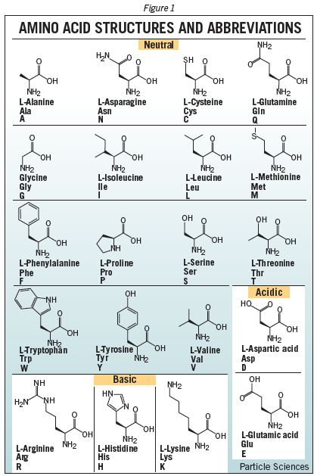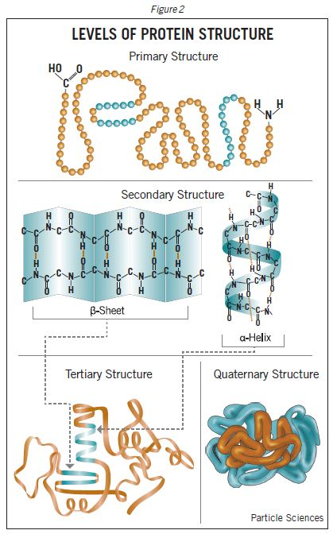

SYNTHESIS
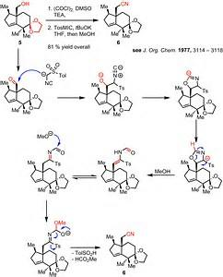

THE CONTACT PROCESS
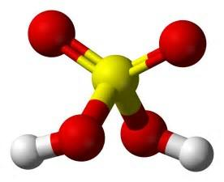

Sulfuric Acid (H₂SO₄)
- commercially important raw material
- more sulfuric acid made than any other compound – Contact Process
- fertilisers, paints and pigments, detergents, car batteries, laboratory acid
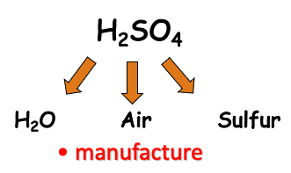
Steps:
① Formation of SO₂
either S + O₂ 🡪 SO₂
or 2ZnS + 3O₂ 🡪 2SO₂ + 2ZnO

② Formation of SO₃ the Contact Process
2SO₂ + O₂ 🡪 2SO₃ exothermic

③ Formation of Oleum
SO₃ + H₂SO₄ 🡪 H₂S₂O₇
(the direct combination of SO₃ with water is too exothermic and forms a fine mist of acid)

④ Dilution of Oleum
H₂O + H₂S₂O₇ 🡪 2H₂SO₄
the oleum is diluted to give the desired concentration of sulphuric acid

Take a look at this equilibrium more closely
2SO₂ + O₂ 🡨🡪 2SO₃ exothermic

Factors:
- catalyst (V₂O₅)
- temperature (450ºC)
- pressure (1-2 atmospheres)
these are compromise conditions

catalyst:
- The catalyst works best as the temperature increases
- Provides an alternative path with a lower E_{act}
- Speeds up time taken to achieve equilibrium
- Several catalyst beds used to achieve equilibrium in less time

Temperature:
- The yield of SO₃ increases as T is decreased
- However
- Catalyst does not work if T is too low
- Rate of attainment of equilibrium is slow if T is too low

Pressure
- The yield of SO₃ increases as P is increased
- High pressure is costly $$$

THE HABER PROCESS
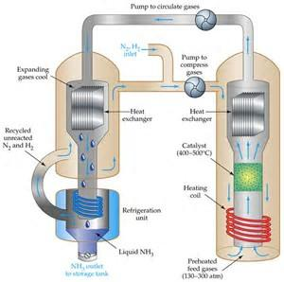

Reversible Reactions
The Haber process is a REVERSIBLE reaction
N_{2(g)} + 3H_{2(g)} 🡨🡪 2NH_{3(g)} (+ heat)
nitrogen + hydrogen 🡨🡪 ammonia
A reversible reaction is one where the products of the reaction can themselves react to produce the original reactants.

If you don’t let any reactants or products escape, both forward and backward reactions can happen at the same time. Reactants make products, and, at the same time, products make reactants.
When the forward and backward reactions go on at the same rate a state of dynamic equilibrium exists.

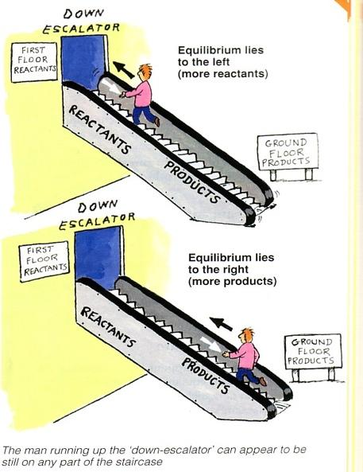
(In the Haber process we want the dynamic equilibrium to move to the right – so that lots of ammonia is made (and not much N and H is left around))

Factors that can affect a reversible reaction include:
- Changing temperature
- Changing concentration
- Changing pressure

IMPROVING THE YIELD OF AMMONIA IN THE HABER PROCESS
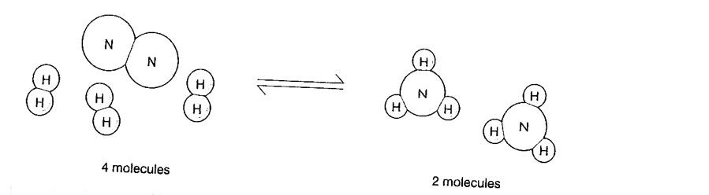
Effect of pressure
On the left hand side there are 4 moles of gas, whilst on the right hand side there are 2 moles
Any increase in pressure will favour the forward reaction to produce more ammonia.
This is because the forward reaction will tend to decrease the pressure in the system.

In the Haber process the pressure is set as high as possible to give the best % yield.
High pressure containers are VERY expensive.
It could be possible to carry out the reaction at 1000 atmospheres – but this would not be economical (it would cost more than the product is worth).
The typical pressure used is 200 to 350 atmospheres.

The reaction produces heat when it moves to the right.
This means that a LOWER temperature would favour the forward reaction, BUT….
Reactions go slower at lower temperatures!
In operating the Haber process you have to decide what is more important, the higher YIELD you can get at lower temperatures or the higher RATE at higher temperatures.

In order to get ammonia produced at a quicker RATE the reaction is carried out at a high temperature (450ºC).
It is better to get just a 10% yield in 20 seconds (at a high temperature) that a 20% in 60 seconds (at a lower temperature)

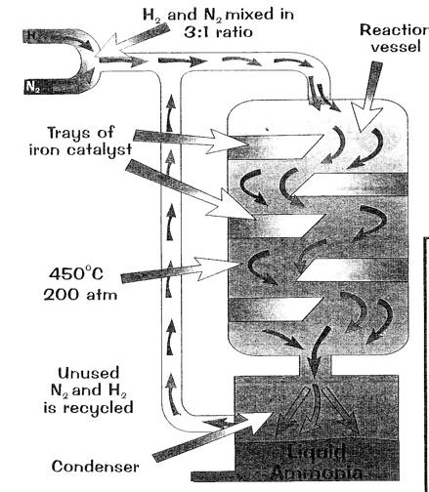
An IRON catalyst makes the reaction occur more quickly, (it does not affect the % yield i.e. the position of the dynamic equilibrium).
Without the catalyst the temperature would have to be much higher (this would lower the yield).

Removing the ammonia from the system also pushes the reaction to the right so more ammonia is produced to replace it.

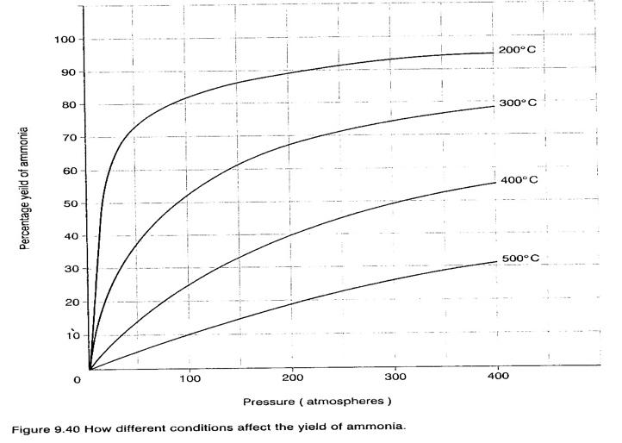

LIMITING REAGENT
Limiting Reagent: the reagent that is completely used up in a chemical reaction.
Excess Reagent: reagent not completely used up in a chemical reaction.

Example:
Find the limiting reagent when 1.22g O₂ reacts with 1.05g H₂ to produce H₂O.
- There are two solution methods you could use.
- In both methods, the first step is to convert the mass to moles.

Method 1
- Use the moles of one reactant to calculate the necessary moles of the other reactant to fully react.
- Compare the calculated value with the actual value to see if this reagent is excess or limiting.

Example:
Find the limiting reagent when 1.22g O₂ reacts with 1.05g H₂ to produce H₂O.
Answers using method 1:
  - Convert mass to moles:
0.038 mol O₂, 0.5 mol H₂
  - Calculate H₂ moles necessary to react with O₂:
0.076 mol H₂.
  - Compare 0.076 mol H₂
to actual mol of H₂ (0.5mol H₂),
  - Since 0.5 mol H₂ is more than 0.076 mol H₂,
H₂ is the excess reagent and O₂ is the limiting reagent.

Method 2
Use the moles of each of the reactant to calculate one of the products.
The reagent that gave the smaller calculated value of product is the limiting reagent.
The actual value of the amount of product is the smaller of the calculated values.

Example: Find the limiting reagent when 1.22g O₂ reacts with 1.05g H₂ to produce H₂O.
Answers using Method 2:
  - Convert mass to moles:
0.038 mol O₂, 0.5 mol H₂
  - Calculate H₂O moles produced by using each of the reactants:
    - Using O₂: 0.076 mol H₂O.
    - Using H₂: 0.5 mol H₂O.
  - The actual amount H₂O produced is the smaller one of the two values(0.076mol H₂O).
  - O₂ is the limiting reagent, since O₂ was used in the calculation of the 0.076mol H₂O.

YIELD
Silicon carbide (SiC) which is also known as carborundum is the very hard, black substance use on many abrasive papers (sand paper). It is made by heating a mixture of quartz (SiO₂) and carbon (C) to a high temperature.
SiO_{2(s)} + 2C_{(s)} 🡪 SiC_{(s)} + CO_{2 (g)}
What is the maximum amount of carborundum that can be produced when 1.0kg of SiO₂ reacts with 1.0kg of C?
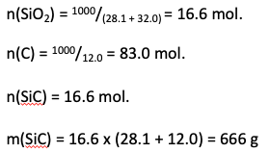

PERCENTAGE YIELD
Chlorobenzene, C₆H₅Cl, is used in the production of chemicals such as aspirinand dyes. One way that chlorobenzene is prepared is by reacting benzene, C₆H₆, with chlorine gas according to the following BALANCED equation.
C₆H_{6 (l)} + Cl_{2 (g)} C₆H₅Cl _{(s)} + HCl _{(g)}
- What is the theoretical yield if 45.6 g of benzene react?
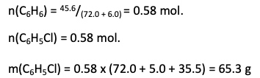

- If the actual yield is 63.7 g of chlorobenzene, calculate the percent yield.

